PROJECT REPORT ON:

**Hospital Management System**

SUBMITTED BY:

Mr. Aryan M Shivgunde

&

Sarvesh Pawar

(Bachelor of Computer Application)

SUBMITTED TO:

**Tilak Maharashtra Vidyapeeth, Pune**

(2024 - 25)

**OM SAI INFOTECH**

**OM SAI INFOTECH**

Office 303, Saptashree Guruprerna Society, Opposite Gaodevi Ground Gaodevi Road, station, Thane West, Thane, Maharashtra 400602

DATE: 22nd May 2025

DIRECTOR RECOMMENDATION

To,

The Register,

Tilak Maharashtra University,

Pune.

**Subject:- Request approval of BCA II (SEM - IV) Project Report**

We are recommending the report entitled - “**Hospital Management System**” prepared **Aryan M Shivgunde and Sarvesh Pawar.** As per partial fulfilment of university requirement for the award of **Bachelor of Computer Application (BCA II, SEM - IV)** degree of **TILAK MAHARASHTRA VIDYAPEETH, OM SAI INFOTECH.**

**OM SAI INFOTECH**

Office 303, Saptashree Guruprerna Society, Opposite Gaodevi Ground Gaodevi Road, station, Thane West, Thane, Maharashtra 400602

DATE: 22nd May 2025

CERTIFCATE

To,

The Register,

Tilak Maharashtra University,

Pune.

Subject: - Request approval of BCA II (SEM - IV) Project Report

We are recommending the report entitled - “**Hospital Management System**” prepared **Mr. Aryan M Shivgunde and Sarvesh Pawar.** As per partial fulfilment of university requirement for the award of **Bachelor of Computer Application (BCA II, SEM - IV)** degree of **TILAK MAHARASHTRA VIDYAPEETH, OM SAI INFOTECH.**

Project Guide:

Mrs. Anjali Patak

Director

External Sign:

ACKNOWLEDGEMENT

ACKNOWLEDGEMENT

We are very glad that we have successfully completed our assignment on time. We appreciate all the helpers for helping out along the way of this development. We thank all of them for their helpful attitude.

We would like to express our sincere gratitude to our lecturer, Mrs. Anjali Phatak, for her guidance throughout this project. Her instruction on various software development methodologies and their benefits, as well as the fundamentals of UML Design, provided a strong foundation for our work.

We are also thankful to everyone who supported us in completing this project. This includes the faculty of our department who assisted with our research needs.

We are proud to have successfully finished this project on schedule. We appreciate the assistance we received from all those who helped us along the way, particularly their positive and supportive attitude.

**CONTENTS**

1. introduction 1-1

1.1 Introduction 1-1

1.2 OBJECTIVE AND SCOPE of technical consultancy services 1-1

1.3 scope 1-1

1.4 purpose 1-1

1.5 definition, acronyms & abreviations 1-2

1.6 advantage 1-2

2. project anaysis 2-1

2.1 PROJECT profile 2-1

2.2 existing system 2-1

2.3 need for a new system 2-1

2.4 functionalities 2-2

3. system analysis 3-1

3.1 harware requiremenet 3-1

3.2 software requiremenet 3-1

4. system design 4-2

4.1 flowchart 4-2

4.2 uml diagram 4-3

4.3 enterprise relationship er-diagram 4-3

4.4 use-case diagram 4-5

4.5 class diagram 4-7

4.6 activity diagram 4-11

5. data dictonary 5-1

5.1 user details 5-1

5.2 CONTACT DETAIL 5-1

5.3 ADMIN DETAIL 5-1

5.4 DOCTOR DETAIL 5-2

5.5 PATIENT PAYMENT DETAIL 5-2

5.6 STAFF PAYMENT DETAIL 5-3

6. IMPLEMENTATION OF PROJECT 6-1

6.1 OVERVIEW OF TECHNOLOGIES USED 6-1

6.2 code 6-2

6.2.1 C# code 6-2

6.2.2 Html code 6-14

6.2.3 Database code 6-34

6.3 snapshots / input output design 6-38

6.3.1 patient & admin Verify email & reset password 6-38

6.3.2 patient & admin Register Page: 6-39

6.3.3 patient & admin Login page: 6-40

6.3.4 patient dashboard page: 6-41

6.3.5 patient contact page: 6-44

6.3.6 patient appointment booking page: 6-44

6.3.7 patient profile page: 6-45

6.3.8 Doctor admin dashboard page: 6-46

6.3.9 registered doctor in admin dashboard page: 6-47

6.3.10 admin profile page: 6-48

7. testing 7-1

8. conclusion 8-1

9. future enhancement 9-1

10. bibliography 10-1

# introduction

## 1.1 Introduction

The Hospital Management System (HMS) is a software solution designed to manage hospital operations efficiently. It streamlines administrative tasks, enhances patient care, and facilitates better communication between hospital staff. The system integrates various modules, including patient management, appointment scheduling, billing, inventory management, and reporting.

## 1.2 OBJECTIVE AND SCOPE of technical consultancy services

* As To streamline hospital workflows and administrative processes.
* To digitize patient records for quick access and better management.
* To improve communication between doctors, nurses, and administrative staff.
* To enhance patient experience by reducing wait times and improving service delivery.
* To manage hospital inventory and ensure the availability of necessary medicines and equipment.

## 1.3 scope

The Hospital Management System has multiple aspect hospital operations are as following:

* Patient Management: Registration, medical history, and treatment tracking.
* Doctor Management: Doctor profiles, schedules, and appointments.
* Appointment Scheduling: Online and offline appointment booking.
* Billing and Payments: Automated invoice generation and payment tracking.
* Pharmacy and Inventory Management: Stock tracking and supply management.
* Reporting and Analytics: Data-driven insights for hospital performance evaluation.

## 1.4 purpose

This software will help the company to be more efficient in registration of their patients and manage appointments, records of patients. It enables doctors and admin to view and modify appointments schedules if required. The purpose of this project is to computerize all details regarding patient details and hospital details.

## 1.5 definition, acronyms & abreviations

1. Cardiologist - treats heart disease.
2. Pediatrician - treats infants, toddlers, children and teenagers.
3. Plastic Surgeon - restores, reconstructs, corrects or improves in the shape and appearance of damaged body structures, especially the face.
4. Psychiatrist - treats patients with mental and emotional disorders.
5. Ophthalmologist - treats eye defects, injuries, and diseases
6. ENT- Ear, Nose and Throat Specialist.
7. Dental doctor: Treats any problem related to teeth of patients such as teeth root canal, arrange teeth orientation using braces, etc.
8. Bariatric surgery: Treats Bariatric surgery disease
9. Breast surgery: Treats the breast of women if they have breast cancer.
10. Cancer: Treats Cancer disease.
11. Chest medicine: Given medicine to patients who have chest issues.
12. Endocrinology & Diabetes: Treats patients for diabetes and endocrinology disease.

* SRS: Software Requirement Specification
* BG: Blood Group
* ER: Enterprise Relationship Diagram
* ENT: Ear, Nose, Throat Specialist

✓ Appt – Appointment.

✓ Sign-up - Creating New User.

✓ Log-in - Logging in Existing User.

✓ Add – Address.

## 1.6 advantage

The system automates the manual procedure of managing hospital activities.

* Doctors can view their patients’ treatment records and details easily.
* It even generates an instant bill.
* The system is convenient and flexible to be used.
* It saves their time, efforts, money and resources.

# project anaysis

## 2.1 PROJECT profile

|  |  |
| --- | --- |
| Project title | Unity Hospital Website |
| Objectives | To provides a distinctive and engaging platform for building interactive Unity website |
| Front End Tool | ASP.Net |
| Back End Tool | C# |
| Tool Type of Application | Web Application |
| Internal Guide | Mrs. Anjali Patak |

## 2.2 existing system

Hospital websites serve as a digital gateway for patients, healthcare professionals, and the general public to access medical services and information. They typically provide details about hospital facilities, departments, doctors, appointment booking, emergency services, patient records, and contact information. Some hospital websites also offer telemedicine services, health blogs, and online bill payments. A well-designed hospital website enhances patient experience by offering easy navigation, quick access to essential services, and a secure platform for medical records. Key features include:

* User-Friendly Interface – Ensures accessibility for all users, including elderly patients and those with disabilities.
* Appointment Booking System – Allows patients to schedule consultations online.
* Doctor and Department Directory – Provides information on available specialists and their expertise.
* Emergency and Contact Information – Highlights emergency numbers and hospital locations.
* Patient Portal – Enables secure access to medical records, test results, and prescriptions.
* Telemedicine Services – Facilitates virtual consultations for remote patient care.
* Billing and Online Payments – Simplifies payment processes for treatments and consultations.

## 2.3 need for a new system

A new hospital website system is essential to improve patient care, streamline hospital operations, and enhance digital healthcare services. Many existing hospital websites lack modern features, user-friendly interfaces, and seamless integration with healthcare technologies. Key Reasons are as following:

* Enhanced User Experience – A modern, intuitive design ensures easy navigation for patients and healthcare providers.
* Improved Appointment System – A more efficient online booking system reduces wait times and enhances scheduling.
* Secure Patient Portal – Provides safe access to medical records, prescriptions, and lab results.
* Telemedicine Integration – Enables virtual consultations for remote and emergency healthcare.
* Better Emergency Response – Quick access to emergency contacts, ambulance services, and real-time updates.
* Advanced Billing and Payment System – Allows online payments and insurance integration for seamless transactions.
* Mobile-Friendly & Responsive Design – Ensures accessibility across devices for patients on the go.
* Integration with AI & Automation – Helps in chatbot assistance, automated reminders, and personalized healthcare suggestions.

## 2.4 functionalities

A hospital website provides essential features to enhance patient care, streamline hospital operations, and improve accessibility to healthcare services. Key Functionalities are as following:

* User Registration & Login – Secure access for patients, doctors, and staff.
* Online Appointment Booking – Patients can schedule, reschedule, or cancel appointments.
* Doctor & Department Directory – Lists available doctors, specialties, and contact details.
* Emergency Services Information – Displays emergency contacts, ambulance services, and nearest facilities.
* Patient Portal – Secure access to medical records, prescriptions, and lab results.
* Telemedicine & Virtual Consultations – Enables online doctor consultations and remote patient care.
* Billing & Online Payments – Allows patients to pay bills, check insurance details, and download invoices.
* Health Blog & Resources – Provides medical articles, health tips, and hospital news.
* Feedback & Support System – Patients can submit queries, complaints, and feedback.
* Multilingual & Accessibility Support – Ensures usability for diverse patient groups and people with disabilities.

# system analysis

## 3.1 harware requiremenet

|  |  |
| --- | --- |
| Component | Specification |
| Processor | AMD or higher |
| RAM | 512MB or more |
| Hard Disk | 10GB or more |
| Devices | Laptop, PC, Smartphones, Tablets, or any device capable of running a web browser |
| Keyboard | Normal or Multimedia |
| Mouse | Compatible Mouse |

## 3.2 software requiremenet

|  |  |
| --- | --- |
| Component | Specification |
| Operating System | Windows 10, Windows 8, Android, MacOS, or any operating system compatible with modern  web browsers or higher |
| Browser | Brave, Chrome, Edge, Firefox, Safari, or any modern browser with HTML5 and CSS3 support |
| Internet Connection | Broadband connection recommended for optimal performance |
| Screen Resolution | 400x700 or higher |
| Plugins | No additional plugins required |

# system design

## 4.1 flowchart

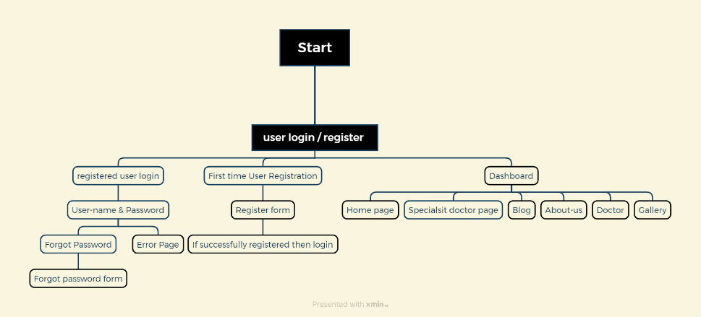

Con Breakdown of the Flowchart:

1. User Login / Register Section

Registered User Login

Username & Password

Forgot Password

If Successful then forgot Password Form otherwise Error Page will occur.

First-Time User Registration

Register Form

If Successfully Registered, Then Login

2. Dashboard Section

Home Page

Specialist Doctor Page

Blog

About Us

Doctor

Gallery

## 4.2 uml diagram

UML serves as a standardized modeling language for visualizing, specifying, constructing, and documenting the system's architecture and functionalities. The diagrams provided offer comprehensive insights into the application's design, facilitating better understanding and communication among stakeholders. Below are the key UML diagrams featured in this section:

* Use Case Diagram: Illustrates the interactions between users and the system, identifying various use cases and their relationships.
* Sequence Diagram: Presents the chronological sequence of interactions between system components or actors, depicting the flow of messages.
* Class Diagram: Represents the static structure of the system, depicting classes, their attributes, methods, and relationships.
* Activity Diagram: Depicts the flow of activities within the system, illustrating the sequence of actions and decision points.

These UML diagrams collectively provide a comprehensive overview of the Unity hospital application, aiding in its analysis, design, and development phases.

## 4.3 enterprise relationship er-diagram

The ER diagram provided offers insight into the database structure of the Unity website application.

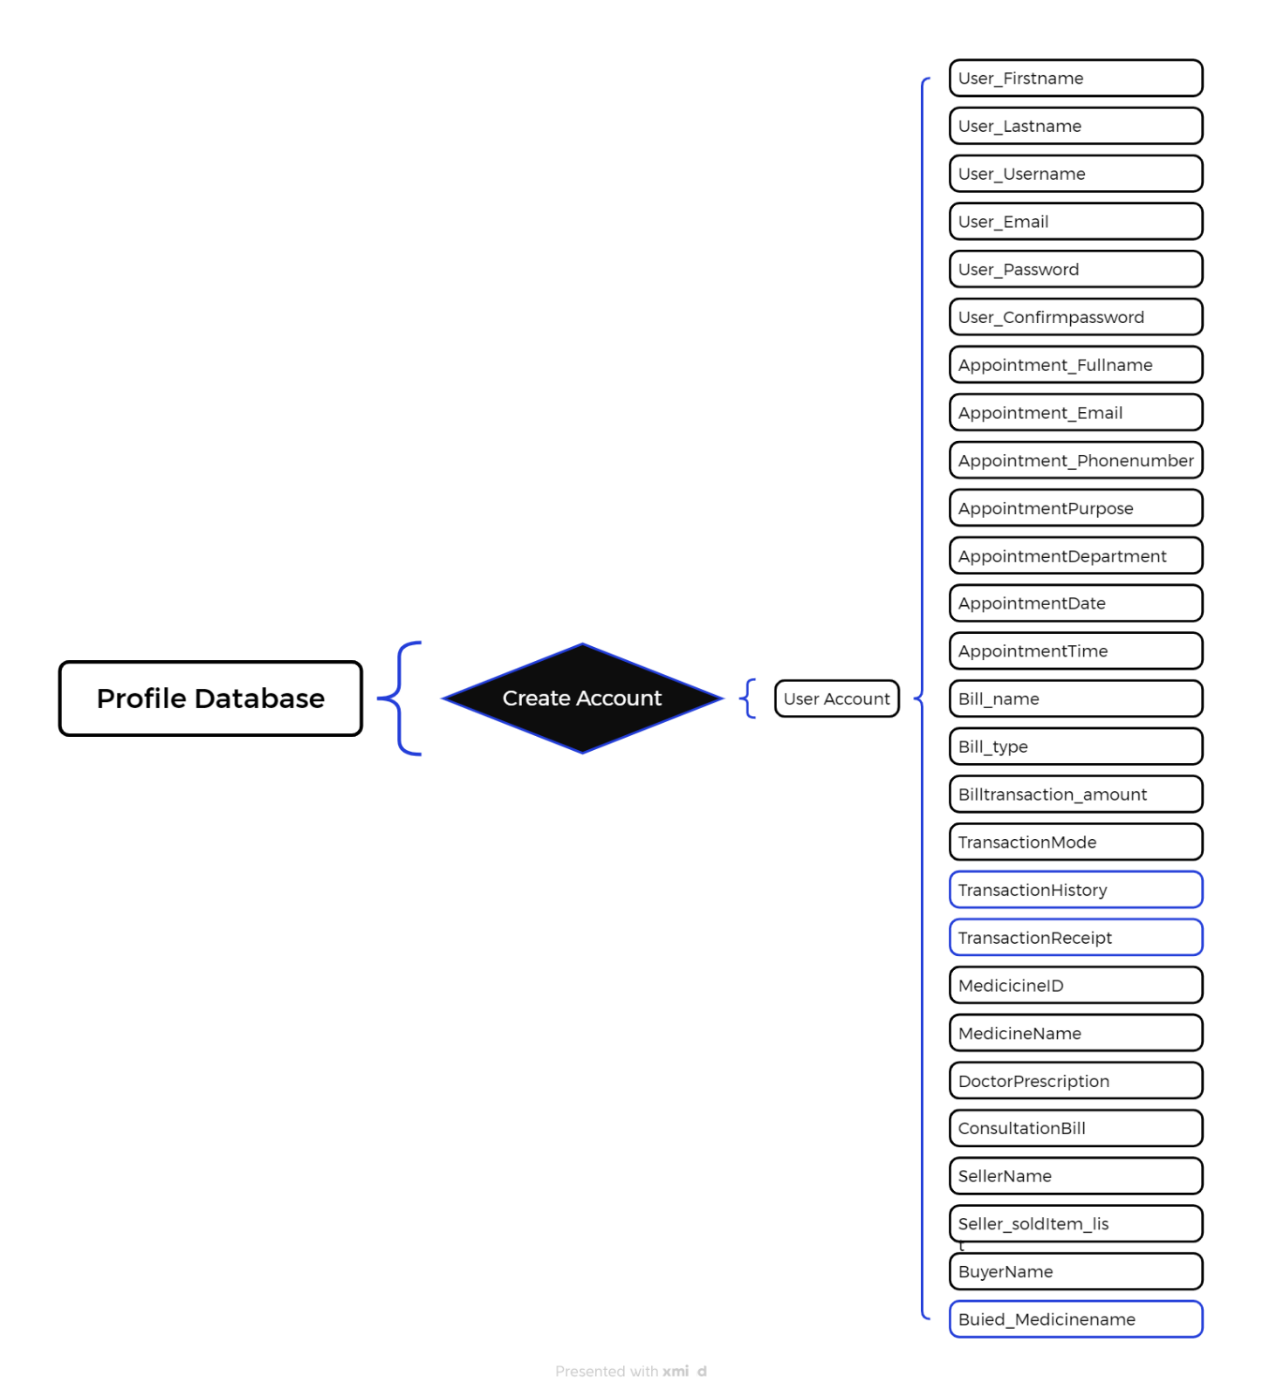

Below is a comprehensive breakdown of its components and their significance:

* User Account Entity: At the core of the diagram lies the User Account entity, serving as the focal point for user profiles within the application.
* The Profile Database serves as the central storage system.
* The Create Account process is a decision-making action in the system, leading to the creation of a User Account.
* The User Account stores various details related to a user, appointments, billing, transactions, and medicine purchases.
  + - Attributes: Associated with the User Account entity are various attributes, each representing distinct sections of a hospital website:
  + Transaction details: Contains the details of transaction.
  + User details: First name, Last name, Email gives a sufficient detail about the user.
  + Medicine details: List the list of medicine in a pharmacy department.
  + Inventory details: The list of inventory who takes medicine for which hospital and sells which medicine at what quantity.
  + Personal Details: The list of personal detail about the user.
* Create Account Process: Indicated by the "Create Account" process, this signifies the initiation of a User Account creation within the profile database.
* Document ID: Each user entry may be associated with a unique Document ID, facilitating identification and retrieval within the database.
* Relationships: The diagram illustrates one-to-many relationships between the User Account entity and its attributes, indicating that a user can have multiple entries for transaction details, etc.

This ER diagram serves as a visual representation of the database architecture underlying the Unity hospital management application. It elucidates the interconnections between different data components and elucidates how user information is organized around the central user profile, enhancing comprehension of the system's data structure.

## 4.4 use-case diagram

Use Case Diagram Overview:

The Use Case Diagram presented in this section illustrates the interactions between various actors - User, Admin, and Viewer - and the corresponding functionalities within the Unity Hospital application. This Use Case Diagram serves as a visual representation of the system's high-level behavior, offering valuable insights into user interactions and system functionalities within the Unity Hospital application.

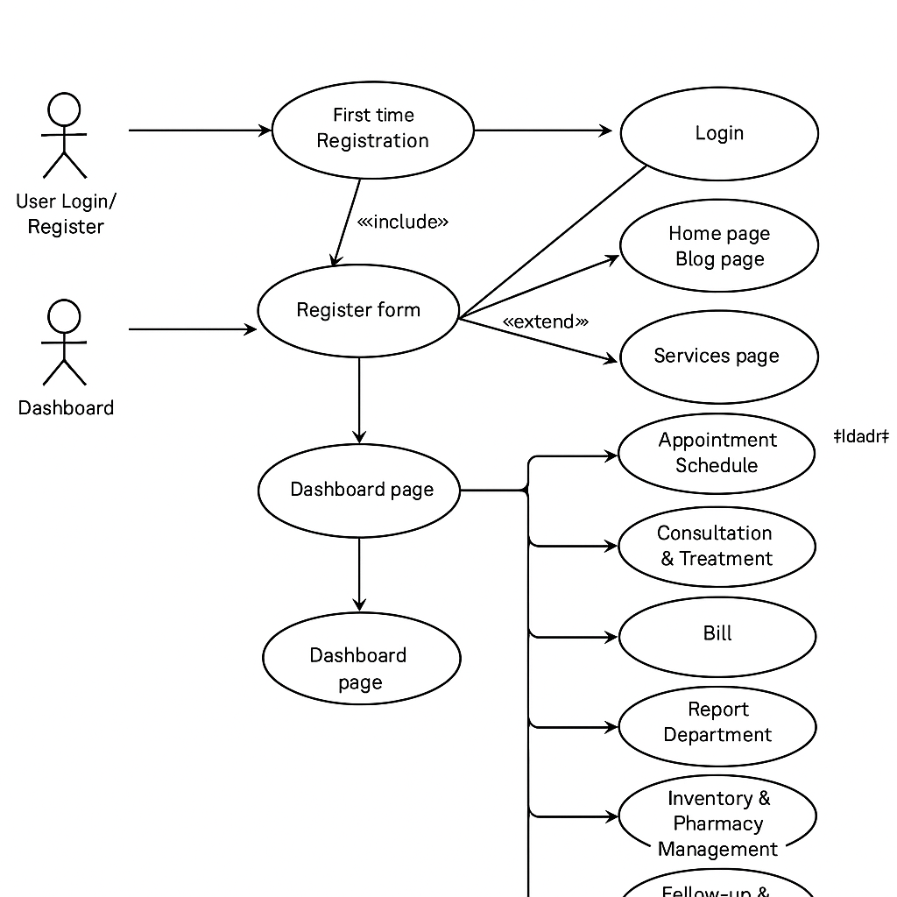User Login / Register

First Time Registration

Users who are registering for the first time fill out a Register Form.

After completing the form, if registration is successful, the user can then log in.

First Time Login

For users who already have an account, they will enter their credentials in the Login Form (username & password).

Dashboard Access

Once successfully logged in, the user is directed to the Dashboard Page. This serves as the central hub for navigating the site.

Main Pages Accessible from Dashboard

Home Page

Generally, provides an overview or welcome information about the platform.

Blog Page

A section for articles, updates, and informational content related to services offered or health tips.

Services Page

Detailed descriptions of the services provided.

From this page, users can further access:

Appointment Schedule

Users can view or set appointments.

Consultation & Treatment

Information on consultations and treatment options.

Bills

Users can manage payments and view billing details.

Report Department

Access to medical reports and related documentation.

Pharmacy & Inventory Management

Information about pharmacy services or inventory checks.

Follow-up & Discharge

Guidance and protocols for patient follow-up or discharge related issues.

About Page

Contains information about the organization, mission, and team.

Doctor List Page

A directory or listings of doctors available for consultation.

Gallery Page

A collection of images related to the services offered or the facility.

## 4.5 class diagram

Class Diagram Overview:

The Class Diagram presented here offers a structured representation of the Unity Hospital Management system website showcasing the classes, interfaces, attributes, and methods that comprise the system. This diagram serves as a fundamental tool for modelling object-oriented systems, providing insights into the system's structure and the interactions between its components. Below is an expanded explanation of each class and its components:

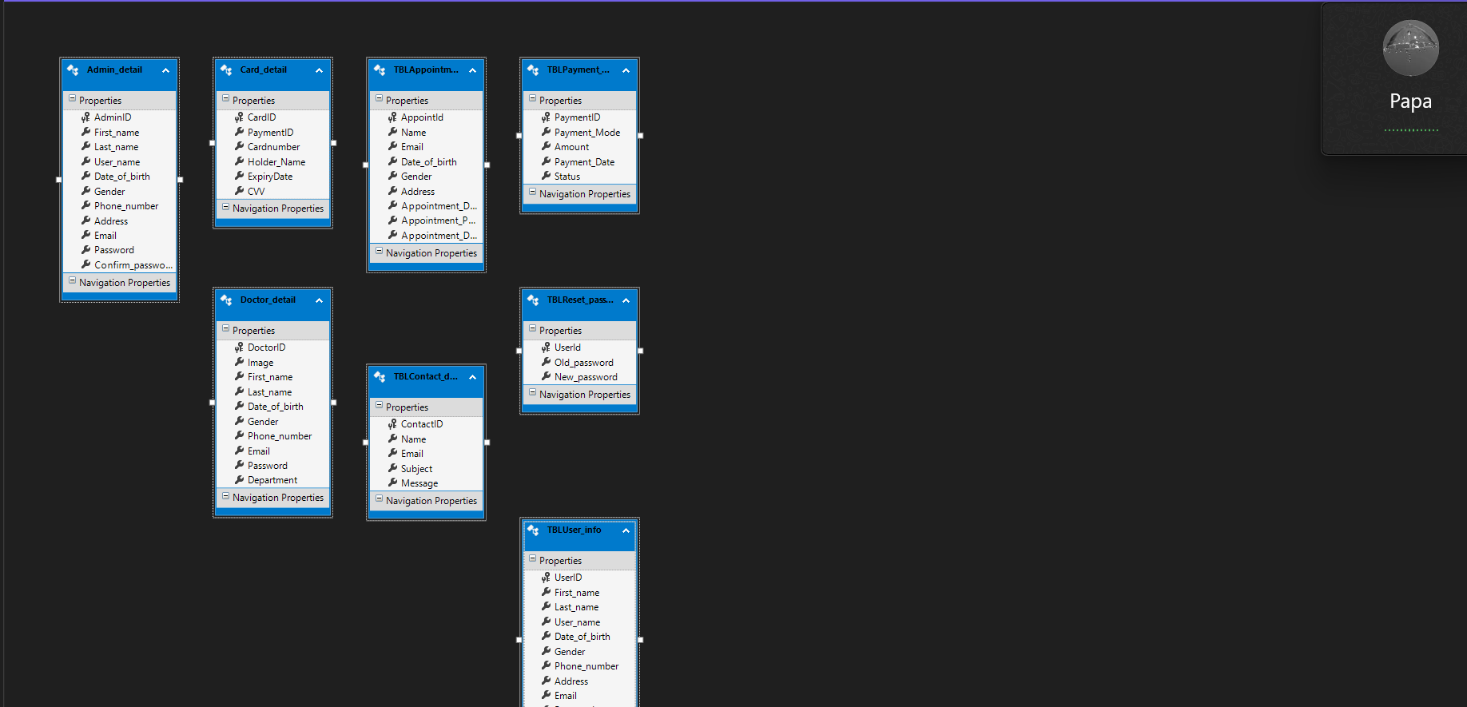

* AdminID (PK)
* First_name, Last_name, User_name
* Date_of_birth, Gender
* Phone_number, Address
* Email, Password, Confirm_password

**2. Card_detail**

**Purpose:** Stores card payment information.  
**Fields:**

* CardID (PK)
* PaymentID (FK to TBLPayment)
* Cardnumber, Holder_Name, ExpiryDate, CVV

**3. TBLAppointment_detail**

**Purpose:** Manages appointment data.  
**Fields:**

* AppointmentID (PK)
* Name, Email, Date_of_birth, Gender
* Address
* Appointment_Date, Appointment_Purpose, Appointment_Doctor

**4. TBLPayment_detail**

**Purpose:** Records payment transactions.  
**Fields:**

* PaymentID (PK)
* Payment_Mode, Amount, Payment_Date, Status

**5. Doctor_detail**

**Purpose:** Contains doctor profiles.  
**Fields:**

* DoctorID (PK)
* Image, First_name, Last_name
* Date_of_birth, Gender
* Phone_number, Email, Password
* Department

**6. TBLContact_detail**

**Purpose:** Handles contact or inquiry messages.  
**Fields:**

* ContactID (PK)
* Name, Email
* Subject, Message

**7. TBLReset_password**

**Purpose:** Supports password reset functionality.  
**Fields:**

* UserId (PK)
* Old_password, New_password

**8. TBLUser_info**

**Purpose:** Stores user account information (likely for patients).  
**Fields:**

* UserID (PK)
* First_name, Last_name, User_name
* Date_of_birth, Gender
* Phone_number, Address

## 4.6 activity diagram

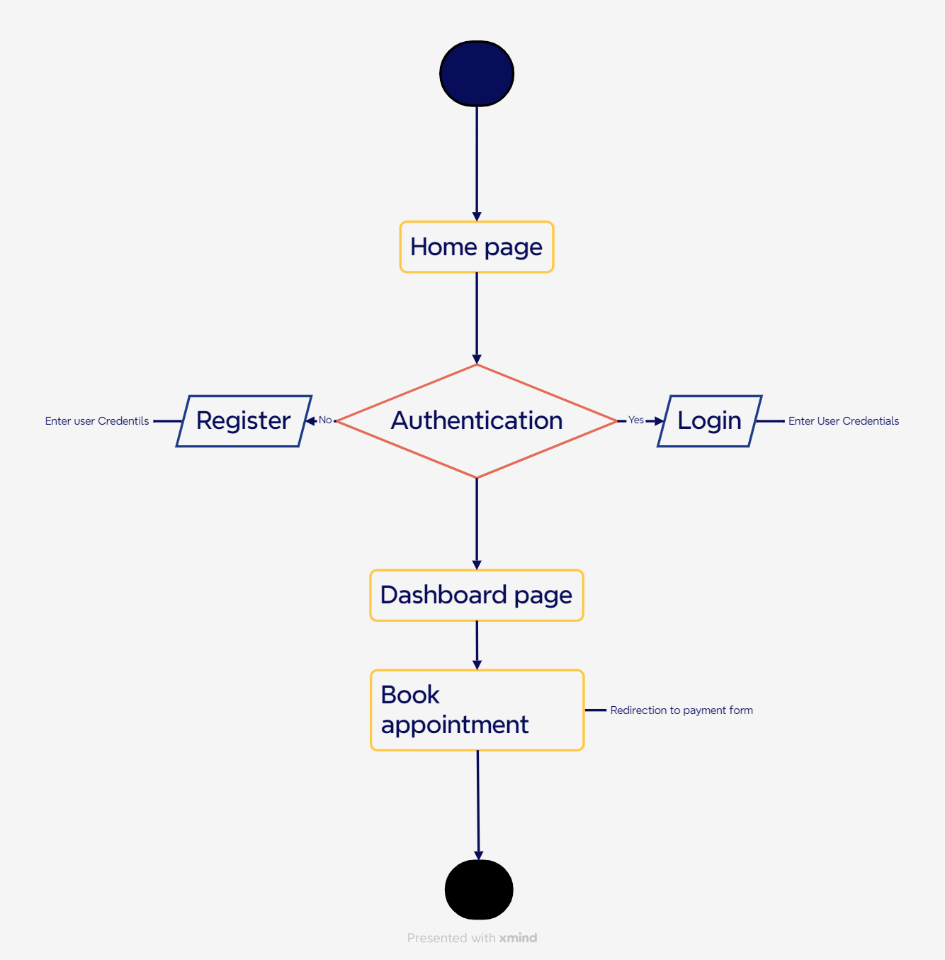

Activity Diagram Overview:

The Activity Diagram provided offers a visual representation of the flow of actions and interactions within the Unity Hospital Management System website user interface.

Detailed Explanation:

Start Point

The flowchart begins at a node labeled "The Inputs Tight."

Decision Node

An important decision is made at this stage, where the pathway diverges based on user input or conditions.

Paths of Execution

Initial Input Check

There appears to be a process to check specific conditions from the initial input.

If the input is recognized as "Yes," the flow continues down one path; otherwise, it diverges to another section.

Further Assessments

For those proceeding from the positive decision:

Several other checks and conditions are assessed, which seem to involve analyzing additional parameters or inputs.

Pathways involve labeled statements like “determine type” and “lead to...,” indicating decisions or actions based on previous inputs.

Final Outputs

The outcome of the series of assessments leads to a conclusion or final result, which appears to be represented in a different area of the diagram.

Conclusions and Actions

Various outcomes based on input conditions likely dictate what action to take next.

The use of decision nodes indicates a structured approach to handling varied scenarios and effectively leading to potential solutions based on the inputs received.

Overall Impressions

Complexity: The flowchart illustrates a systematic approach to problem-solving, showcasing multiple pathways depending on inputs.

Functionality: It appears to serve as a decision support tool, guiding users through a series of choices to reach the most effective resolution.

# data dictonary

## 5.1 user details

|  |  |  |  |
| --- | --- | --- | --- |
| NAME | NULL/NOT NULL | DATA TYPE | KEY |
| UserID | NOT NULL | INT | Primary |
| First_name | NOT NULL | VARCHAR |  |
| Last_name | NOT NULL | VARCHAR |  |
| User_name | NOT NULL | VARCHAR |  |
| Date_of_birth | NOT NULL | VARCHAR |  |
| Gender | NOT NULL | VARCHAR |  |
| Phone_nubmer | NOT NULL | VARCHAR |  |
| Address | NOT NULL | VARCHAR |  |
| Email | NOT NULL | VARCHAR |  |
| Password | NOT NULL | VARCHAR |  |
| Confirm_password | NOT NULL | VARCHAR |  |

## 5.2 CONTACT DETAIL

|  |  |  |  |
| --- | --- | --- | --- |
| NAME | NULL/NOT NULL | DATA TYPE | KEY |
| ContactID | NOT NULL | INT | Primary |
| Name | NOT NULL | VARCHAR |  |
| Email | NOT NULL | VARCHAR |  |
| Subject | NOT NULL | VARCHAR |  |
| Message | NOT NULL | VARCHAR |  |

## 5.3 ADMIN DETAIL

|  |  |  |  |
| --- | --- | --- | --- |
| NAME | NULL/NOT NULL | DATA TYPE | KEY |
| AdminID | NOT NULL | INT | Primary |
| First_name | NOT NULL | VARCHAR |  |
| Last_name | NOT NULL | VARCHAR |  |
| User_name | NOT NULL | VARCHAR |  |
| Date_of_birth | NOT NULL | VARCHAR |  |
| Gender | NOT NULL | VARCHAR |  |
| Phone_nubmer | NOT NULL | VARCHAR |  |
| Address | NOT NULL | VARCHAR |  |
| Email | NOT NULL | VARCHAR |  |
| Password | NOT NULL | VARCHAR |  |
| Confirm_password | NOT NULL | VARCHAR |  |

## 5.4 DOCTOR DETAIL

|  |  |  |  |
| --- | --- | --- | --- |
| NAME | NULL/NOT NULL | DATA TYPE | KEY |
| DoctorID | NOT NULL | INT | Primary |
| Image | NOT NULL | VARBINARY |  |
| Name | NOT NULL | VARCHAR |  |
| Date_of_birth | NOT NULL | VARCHAR |  |
| Gender | NOT NULL | VARCHAR |  |
| Phone_nubmer | NOT NULL | VARCHAR |  |
| Email | NOT NULL | VARCHAR |  |
| Password | NOT NULL | VARCHAR |  |
| Department | NOT NULL | VARCHAR |  |

## 5.5 PATIENT PAYMENT DETAIL

|  |  |  |  |
| --- | --- | --- | --- |
| NAME | NULL/NOT NULL | DATA TYPE | KEY |
| PaymentID | NOT NULL | INT | PRIMARY |
| Payment_Mode | NOT NULL | VARBINARY |  |
| Amount | NOT NULL | VARCHAR |  |
| Status | NOT NULL | VARCHAR |  |
| CardID | NOT NULL | INT | PRIMARY |
| Holder_name | NOT NULL | VARCHAR |  |
| Cardnumber | NOT NULL | VARCHAR |  |
| Expiry_Date | NOT NULL | VARCHAR |  |
| CVV | NOT NULL | VARCHAR |  |

## 5.6 STAFF PAYMENT DETAIL

|  |  |  |  |
| --- | --- | --- | --- |
| NAME | NULL/NOT NULL | DATA TYPE | KEY |
| StaffID | NOT NULL | INT | PRIMARY |
| Staff_name | NOT NULL | VARBINARY |  |
| Qualification | NOT NULL | VARCHAR |  |
| Joining_Date | NOT NULL | DATE |  |
| Age | NOT NULL | INT |  |
| Gender | NOT NULL | CHAR |  |
| Address | NOT NULL | VARCHAR |  |
| Experience | NOT NULL | VARCHAR |  |
| Residence_phone | NOT NULL | VARCHAR |  |
| Phone_number | NOT NULL | VARCHAR |  |
| Email | NOT NULL | VARCHAR |  |

# IMPLEMENTATION OF PROJECT

## 6.1 OVERVIEW OF TECHNOLOGIES USED

In the development of Unity hospital, a robust arsenal of frontend technologies was employed to create a seamless and visually captivating user experience. Here's an in- depth exploration of the frontend technologies utilized:

HTML, CSS, and JavaScript: HTML (Hypertext Markup Language), CSS (Cascading Style Sheets), JavaScript, Asp.net MVC (Model View Controller) form the backbone of frontend development, providing the foundation for creating and styling web pages. HTML defines the structure of web content, while CSS controls its presentation and layout. JavaScript, on the other hand, adds interactivity and dynamic behavior to web pages, enabling features such as animations, form validation, and DOM manipulation.

In Unity Hospital website, HTML, CSS, JavaScript, ASP.Net work in tandem to create the user interface elements, layout, and interactivity. HTML is used to structure the content of the Hospital Management system interface, CSS styles the elements to enhance visual appeal and usability, and JavaScript adds interactive features such as form validation, dynamic content updates, and user interactions.

Integration with HTML, CSS, JavaScript, ASP.Net. In Unity Hospital Management System seamlessly integrates with HTML, CSS, Asp.net & JavaScript to create a cohesive and immersive user experience. The 3D environment is embedded within the web page alongside other frontend elements, allowing for seamless interaction and navigation. JavaScript is used to control the behavior of the website scene, such as handling user inputs, updating object properties, and triggering animations, Django framework enables for creating the website in more interactive.

Conclusion:

In conclusion, the frontend technologies used in Unity hospital website play a crucial role in creating an immersive and engaging user experience. By harnessing the power of HTML, CSS, JavaScript & Asp.net MVC the project offers users a unique platform to showcase their skills and experiences in a visually captivating environment. Moving forward, these frontend technologies will continue to drive innovation and shape the future of web development, paving the way for more immersive and interactive experiences on the web.

## 6.2 code

## 6.2.1 C# code

using QRCoder;

using System;

using System.Collections.Generic;

using System.Drawing.Imaging;

using System.Drawing;

using System.IO;

using System.Linq;

using System.Web;

using System.Web.Mvc;

using System.Xml.Linq;

using Unity_website.Models;

namespace Unity_website.Controllers

{

public class HomeController : Controller

{

// GET: Home

Hospital_appDBEntities Db = new Hospital_appDBEntities();

// GET: Home

public ActionResult Index()

{

return View();

}

public ActionResult Asthama_description()

{

return View();

}

public ActionResult Bariaticsurgery_description()

{

return View();

}

public ActionResult Breastcenter_description()

{

return View();

}

public ActionResult Cancer_description()

{

return View();

}

public ActionResult Chest_description()

{

return View();

}

public ActionResult Dermotology_description()

{

return View();

}

public ActionResult Drentist_description()

{

return View();

}

public ActionResult Ent_description()

{

return View();

}

public ActionResult Endocrinology_and_diabetes_description()

{

return View();

}

[HttpGet]

public ActionResult Book_appointment()

{

return View();

}

[HttpPost]

public ActionResult Book_appointment(TBLAppointment_detail Tbl_appointment)

{

if (Db.TBLAppointment_detail.Any(X => X.Email == Tbl_appointment.Email))

{

Response.Write("<script>alert('Data already exists.')</script>");

}

else

{

Db.TBLAppointment_detail.Add(Tbl_appointment);

Db.SaveChanges();

Response.Write("<script>alert('Data saved.')</script>");

return RedirectToAction("Payment_section", "Home");

}

return View();

}

[HttpGet]

public ActionResult Payment_section()

{

return View();

}

[HttpPost]

public ActionResult Payment_section(TBLPayment_detail Payment_obj, DateTime dateTime)

{

Payment_obj.Status = "Pending";

Payment_obj.Payment_Date = dateTime.ToString();

Db.TBLPayment_detail.Add(Payment_obj);

Db.SaveChanges();

if (Payment_obj.Payment_Mode == "Card")

return RedirectToAction("EnterCard_detail", "Home", new { PaymentID = Payment_obj.PaymentID });

else if (Payment_obj.Payment_Mode == "UPI")

return RedirectToAction("Upipayment_section", "Home", new { PaymentID = Payment_obj.PaymentID });

else

return View();

}

public ActionResult EnterCard_detail()

{

return View();

}

[HttpPost]

public ActionResult EnterCard_detail(Card_detail Detail)

{

Db.Card_detail.Add(Detail);

var Payment = Db.TBLPayment_detail.Find(Detail.PaymentID);

if (Payment != null)

{

Payment.Status = "Completed";

Db.SaveChanges();

}

return RedirectToAction("Bill_section", new { Id = Detail.PaymentID });

}

public ActionResult Bill_section(int Id)

{

var Q = Db.TBLPayment_detail.Include("Card_detail").FirstOrDefault(P => P.PaymentID == Id);

return View(Q);

}

[HttpGet]

public ActionResult Upipayment()

{

return View();

}

[HttpPost]

public ActionResult Upipayment(int PaymentID)

{

var UpiString = "upi://pay?pa=yourupi@bank&pn=YourName&am=10"; // Update as needed

ViewBag.UPIString = UpiString;

ViewBag.PaymentID = PaymentID;

var Pay_obj = Db.TBLPayment_detail.Find(PaymentID);

Pay_obj.Status = "Completed";

Db.SaveChanges();

return RedirectToAction("Bill_section", new { ID = PaymentID });

}

public ActionResult Register()

{

return View();

}

[HttpPost]

public ActionResult Register(TBLUser_info Tbl_obj)

{

if (Db.TBLUser_info.Any(X => X.Email == Tbl_obj.Email))

{

ViewBag.Information = "Error";

return View();

}

else

{

Db.TBLUser_info.Add(Tbl_obj);

Db.SaveChanges();

return RedirectToAction("Login", "Home");

}

}

public ActionResult Login()

{

return View();

}

[HttpPost]

public ActionResult Login(TBLUser_info Tbl_obj)

{

var Q = Db.TBLUser_info.Where(X => X.User_name == Tbl_obj.User_name && X.Email == Tbl_obj.Email && X.Password == Tbl_obj.Password);

if (Q != null) {

Session["User_name"] = Tbl_obj.User_name.ToString();

Session["Email"] = Tbl_obj.Email.ToString();

Session["Password"] = Tbl_obj.Password.ToString();

return RedirectToAction("Dashboard_page", "Home");

}

else

{

ViewBag.Notification = "Error";

return View();

}

}

[HttpGet]

public ActionResult Verify_email()

{

return View();

}

[HttpPost]

public ActionResult Verify_email(TBLUser_info Tbl_obj)

{

var Q = Db.TBLUser_info.Where(X => X.User_name == Tbl_obj.User_name && X.Email == Tbl_obj.Email);

if (Q != null)

{

Session["Email"] = Tbl_obj.Email.ToString();

return RedirectToAction("Reset_password", "Home");

}

else

{

ViewBag.Notification = "Error";

}

return View();

}

[HttpGet]

public ActionResult Reset_password()

{

return View();

}

[HttpPost]

public ActionResult Reset_password(TBLReset_password Tbl_obj)

{

if(Db.TBLReset_password.Any(X => X.Old_password == Tbl_obj.Old_password))

{

ViewBag.Notification = "Error";

}

else

{

Db.TBLReset_password.Add(Tbl_obj);

Db.SaveChanges();

return RedirectToAction("Login","Home");

}

return View();

}

public ActionResult Dashboard_page()

{

return View();

}

public ActionResult Specialist_doctor()

{

return View();

}

public ActionResult Doctor()

{

return View();

}

public ActionResult Gallery()

{

return View();

}

[HttpGet]

public ActionResult Contact()

{

return View();

}

[HttpPost]

public ActionResult Contact(TBLContact_detail Tbl_obj)

{

if(Db.TBLContact_detail.Any(D => D.Email == Tbl_obj.Email))

{

Response.Write("<script>alert('Data already exists.')</script>");

}

else

{

Db.TBLContact_detail.Add(Tbl_obj);

Db.SaveChanges();

Response.Write("<script>alert('Data saved.')</script>");

return RedirectToAction("Dashboard_page","Home");

}

return View();

}

public new ActionResult Profile()

{

return View(Db.TBLUser_info.ToList());

}

public ActionResult DrHarshil_description()

{

return View();

}

public ActionResult DrSahil_description()

{

return View();

}

public ActionResult DrDhruv_description()

{

return View();

}

public ActionResult DrVijeta_description()

{

return View();

}

}

}

**Breaking down the C# Code:**

Let us go through each part of the C# code:

* These using directives import necessary .NET libraries and the QRCoder library (for generating QR codes).
* Unity_website.Models brings in Entity Framework model classes (e.g., TBLUser_info, TBLPayment_detail, etc.).
* Each method returns a static view related to different medical departments or the homepage
* Displays and processes the appointment booking form.
* Checks for existing email in the TBLAppointment_detail table before saving new appointment.
* Redirects to the payment section upon successful save.
* Collects payment method details (Card/UPI).
* Saves the payment object with a "Pending" status.
* Redirects to EnterCard_detail or Upipayment_section depending on payment mode.
* Collects card payment details and links them with the payment entry.
* Updates payment status to "Completed".
* Redirects to the bill section.
* Creates a dummy UPI string (update this with actual dynamic values in production).
* Sets payment status to "Completed" and redirects to bill.
* Displays the bill by retrieving the payment record and related card details.
* Verifies user email before allowing password reset.
* Adds new password entry if it’s not a duplicate
* Loads static pages such as dashboard, doctor info, and gallery.
* Displays a list of all users (could be improved with filtering based on session).
* Static pages for doctor profiles.

## 6.2.2 Html code

<!DOCTYPE *html*>

<html *lang*="en">

<head>

    <meta *charset*="UTF-8">

    <meta *name*="viewport" *content*="width=device-width, initial-scale=1.0">

*<!----------------------------------------------------------------------------------------------- WEBSITE LOGO --------------------------------------------------->*

    <link *rel*="shortcut-icon" *href*="../Resources/Assests/IMG/Logo.png" />

*<!----------------------------------------------------------------------------------------------- CSS STYLE LINK --------------------------------------------------->*

    <link *rel*="stylesheet" *href*="../Resources/Assests/CSS/Style.css" />

*<!----------------------------------------------------------------------------------------------- ICON LINK --------------------------------------------------->*

    <link *href*="https://cdn.jsdelivr.net/npm/remixicon@4.5.0/fonts/remixicon.css" *rel*="stylesheet" />

*<!----------------------------------------------------------------------------------------------- WEBSITE TITLE --------------------------------------------------->*

    <title> Unity website </title>

</head>

<body>

*<!----------------------------------------------------------------------------------------------- HEADER --------------------------------------------------->*

    <header *class*="header" *id*="header">

        <nav *class*="nav container">

            <a *href*="@Url.Action("Dashobard_page","Home")" *class*="nav__logo">

                <i *class*="ri-meta-fill"></i> Unity

            </a>

            <div *class*="nav__menu" *id*="nav-menu">

                <ul *class*="nav__list">

                    <li *class*="nav__item">

                        <a *href*="#home" *class*="nav__link">Home</a>

                    </li>

                    <li *class*="nav__item">

                        <a *href*="@Url.Action("Specialist_doctor","Home")" *class*="nav__link">Specialist doctor</a>

                    </li>

                    <li *class*="nav__item">

                        <a *href*="@Url.Action("Gallery","Home")" *class*="nav__link">Gallery</a>

                    </li>

                    <li *class*="nav__item">

                        <a *href*="@Url.Action("About","Home")" *class*="nav__link">About</a>

                    </li>

                    <li *class*="nav__item">

                        <a *href*="@Url.Action("Doctor","Home")" *class*="nav__link">Doctor</a>

                    </li>

                    <li *class*="nav__item">

                        <a *href*="@Url.Action("Book_appointment","Home")" *class*="nav__link">Book Appointment</a>

                    </li>

                    <li *class*="nav__item">

                        <a *href*="@Url.Action("Contact","Home")" *class*="nav__link">Contact-us</a>

                    </li>

                    <li *class*="nav__item">

                        <a *href*="@Url.Action("Profile","Home")" *class*="nav__link">

                            <i *class*="ri-account-box-fill"></i>

                        </a>

                    </li>

                    <li *class*="nav__item">

                        <a *href*="@Url.Action("Login","Home")" *class*="nav__link">Logout</a>

                    </li>

                </ul>

                <div *class*="nav__close" *id*="nav-close">

                    <i *class*="ri-close-line"></i>

                </div>

            </div>

*<!--TOGGLE BUTTON-->*

            <div *class*="nav__toggle" *id*="nav-toggle">

                <i *class*="ri-menu-line"></i>

            </div>

        </nav>

    </header>

    <br /><br />

*<!----------------------------------------------------------------------------------------------- MAIN SECTION --------------------------------------------------->*

    <main *class*="main">

*<!----------------------------------------------------------------------------------------------- HOME PAGE SECTION --------------------------------------------------->*

        <section *class*="home section" *id*="home">

            <div *class*="home__container container grid">

                <div *class*="home__data">

                    <h1 *class*="home__title">

                        Making a big difference with a life care

                    </h1>

                    <h2 *class*="home__subtitle">

                        Providing comprehensive care to patients

                        <br />

Everyone deserves to have their medical needs met end-to-end. With this in mind, Jupiter Hospital has Asia’s Finest Neuro Rehabilitation Centre in Thane, as well as a centre in Indore, to care for individuals who require extensive care to recover from injuries of various kinds.

                    </h2>

                    <br /><br />

                    <img *src*="../Resources/Assests/IMG/Hospital_img.jpg" *class*="home__img" />

                    <h1 *class*="home__title">

                        Providing comprehensive care to patients

                    </h1>

                    <h2 *class*="home__subtitle">

                        Everyone deserves to have their medical needs met end-to-end. With this in mind, Jupiter Hospital has Asia’s Finest Neuro Rehabilitation Centre in Thane, as well as a centre in Indore, to care for individuals who require extensive care to recover from injuries of various kinds.

                    </h2>

                </div>

            </div>

        </section>

*<!----------------------------------------------------------------------------------------------- SPECIALIST DOCTOR SECTION --------------------------------------------------->*

        <section *class*="specialist_doctor section" *id*="specialist_doctor">

            <div *class*="specialistdoctor__data">

                <h1 *class*="specialistdoctor__title">Specialities</h1>

            </div>

            <div *class*="sepecialistdoctor__container container grid">

                <article *class*="specialistdoctor__card">

                    <h1 *class*="specialist_doctorcard__title">

                        Bariatic surgery

                    </h1>

                    <p *class*="specialist_doctorcard__description">

                        If you are seeking bariatric surgery treatment in Thane,

                        <br />

                        choose Unity Hospital as your trusted destination.

                        <a *href*="@Url.Action("Bariaticsurgery_description","Home")">Know more</a>

                    </p>

                </article>

                <article *class*="specialistdoctor__card">

                    <h1 *class*="specialist_doctorcard__title">

                        Breast center care

                    </h1>

                    <p *class*="specialist_doctorcard__description">

                        If you are seeking breast treatment in Thane,

                        <br />

                        choose Unity Hospital as your trusted destination.

                        <a *href*="@Url.Action("Breastcenter_description","Home")">Know more</a>

                    </p>

                </article>

                <article *class*="specialistdoctor__card">

                    <h1 *class*="specialistdoctor__title">Cancer</h1>

                    <p *class*="specialist_doctorcard__description">

                        If you are seeking cancer treatment in Thane,

                        <br />

                        choose Unity Hospital as your trusted destination.

                        <a *href*="@Url.Action("Cancer_description","Home")">Know more</a>

                    </p>

                </article>

                <article *class*="specialistdoctor__card">

                    <h1 *class*="specialistdoctor__title">Chest Medicine</h1>

                    <p *class*="specialist_doctorcard__description">

                        If you are seeking chest medicin treatment in Thane,

                        <br />

                        choose Unity Hospital as your trusted destination.

                        <a *href*="@Url.Action("Chest_description","Home")">Know more</a>

                    </p>

                </article>

                <article *class*="specialistdoctor__card">

                    <h1 *class*="specialistdoctor__title">Dermotology</h1>

                    <p *class*="specialist_doctorcard__description">

                        If you are seeking dermotology treatment in Thane,

                        <br />

                        choose Unity Hospital as your trusted destination.

                        <a *href*="@Url.Action("Dermotology_description","Home")">Know more</a>

                    </p>

                </article>

                <article *class*="specialistdoctor__card">

                    <h1 *class*="specialistdoctor__title">Dental care</h1>

                    <p *class*="specialist_doctorcard__description">

                        If you are seeking dental treatment in Thane,

                        <br />

                        choose Unity Hospital as your trusted destination.

                        <a *href*="@Url.Action("Dentist_description","Home")">Know more</a>

                    </p>

                </article>

                <article *class*="specialistdoctor__card">

                    <h1 *class*="specialistdoctor__title">Ent</h1>

                    <p *class*="specialist_doctorcard__description">

                        Are you looking for an Ear <br /> hospital in

                        <br />Thane that specialises in the diagnosis and treatment of hormonal disorders?

                        <a *href*="@Url.Action("Ent_description","Home")">Know more</a>

                    </p>

                </article>

                <article *class*="specialistdoctor__card">

                    <h1 *class*="specialistdoctor__title">Endnocrinology and Diabetes</h1>

                    <p *class*="specialist_doctorcard__description">

                        Are you looking for an Endocrinology and diabetes care center <br /> hospital in

                        <br />Thane.

                        <a *href*="@Url.Action("Uriology_description","Home")">Know more</a>

                    </p>

                </article>

                <article *class*="specialistdoctor__card">

                    <h1 *class*="specialistdoctor__title">Uriology</h1>

                    <p *class*="specialist_doctorcard__description">

                        Are you looking for an Uriology and diabetes care center <br /> hospital in

                        <br />Thane that specialises in the diagnosis

                        <br />and treatment of hormonal disorders?

                        <a *href*="@Url.Action("Endocrinologyanddiabetes_description","Home")">Know more</a>

                    </p>

                </article>

            </div>

        </section>

*<!----------------------------------------------------------------------------------------------- ABOUT PAGE SECTION --------------------------------------------------->*

        <section *class*="about section" *id*="about">

            <div *class*="about__container container grid">

                <div *class*="about__data">

                    <h1 *class*="about__title">About Us</h1>

                    <iframe *src*="https://player.vimeo.com/video/33787650" *class*="about__video"></iframe>

                    <p *class*="about__description">

                        UNITY Hospital is a multi/super speciality hospital located at the prime location of Vaishnodevi Circle, SG Road, Ahmedabad; with state-of-the-art facilities & treatments at an affordable cost, encompassing wide spectrum of accurate diagnostics and elegant therapeutics created on the philosophical edifice of patient and ethical centricity ensuring humanistic dispensation.

                        <br />

                        Multiple Options For Treatment.

                        <br />Full Of Latest Technologies and Equipments.

                        <br />Best Hospital Of 2020 Award Winner.

                        <br />24/7 Ambulance Support.

                        <br />Eminent and Experienced Doctors.

                        <br />Vision: Ensuring ‘well being’ as a humane commitment to enliven humanity.

                        <br />Mission: The ‘well being’ ensured by extension of Available, Accessible, Affordable, Safe, Efficacious, Professional and Ethical.

                        <br />Core Values: Team Work, Integrity, Responsibility and Ethics.

                    </p>

                </div>

            </div>

        </section>

        <br /><br /><br /><br /><br /><br /><br /><br /><br /><br /><br /><br />

*<!----------------------------------------------------------------------------------------------- DOCTOR PAGE SECTION --------------------------------------------------->*

                                                                          <section *class*="doctor section" *id*="doctor">

                                                                              <div *class*="doctor__container container grid">

                                                                                  <div *class*="doctor__data">

                                                                                      <h1 *class*="doctor__title">Doctors</h1>

                                                                                  </div>

                                                                                  <div *class*="doctorcard__container">

                                                                                      <div *class*="doctorcard__item">

                                                                                          <table>

                                                                                              <tr>

                                                                                                  <td>

                                                                                                      <div *class*="card__body">

                                                                                                          <h1 *class*="card__title">

                                                                                                              <a *href*="../Views/Home/DrHarshil_description.cshtml">

                                                                                                                  <img *src*="../Resources/Assests/IMG/Team/1.jpg" />

                                                                                                                  <br />

                                                                                                                  DR HARSHIL PATEL

                                                                                                              </a>

                                                                                                          </h1>

                                                                                                          <p *class*="card__description">

                                                                                                              Child nurse

                                                                                                          </p>

                                                                                                      </div>

                                                                                                  </td>

                                                                                                  <td>

                                                                                                      <div *class*="card__body">

                                                                                                          <h1 *class*="card__title">

                                                                                                              <a *href*="../Views/Home/DrSahil_description">

                                                                                                                  <img *src*="../Resources/Assests/IMG/Team/2.jpg" />

                                                                                                                  <br />

                                                                                                                  DR SAHIL ACHHAVA

                                                                                                              </a>

                                                                                                          </h1>

                                                                                                          <p *class*="card__description">

                                                                                                              Neurology

                                                                                                          </p>

                                                                                                      </div>

                                                                                                  </td>

                                                                                                  <td>

                                                                                                      <div *class*="card__body">

                                                                                                          <h1 *class*="card__title">

                                                                                                              <a *href*="../Views/Home/DrDhruv_description.cshtml">

                                                                                                                  <img *src*="../Resources/Assests/IMG/Team/3.jpg" />

                                                                                                                  <br />

                                                                                                                  DR DHRUV SHAH

                                                                                                              </a>

                                                                                                          </h1>

                                                                                                          <p *class*="card__description">

                                                                                                              General surgery

                                                                                                          </p>

                                                                                                      </div>

                                                                                                  </td>

                                                                                                  <td>

                                                                                                      <div *class*="card__body">

                                                                                                          <h1 *class*="card__title">

                                                                                                              <a *href*="~/Views/Home/DrVijeta_description.cshtml">

                                                                                                                  <img *src*="../Resources/Assests/IMG/Team/4.jpg" />

                                                                                                                  <br />

                                                                                                                  DR VIJETA KUMARI

                                                                                                              </a>

                                                                                                          </h1>

                                                                                                          <p *class*="card__description">

                                                                                                              Health Checkup

                                                                                                          </p>

                                                                                                      </div>

                                                                                                  </td>

                                                                                                  <td>

                                                                                                      <div *class*="card__body">

                                                                                                          <h1 *class*="card__title">

                                                                                                              <a *href*="~/Views/Home/DrVijeta_description.cshtml">

                                                                                                                  <img *src*="../Resources/Assests/IMG/Team/5.jpg" />

                                                                                                                  <br />

                                                                                                                  DR SANGEETA PARVEENKUMARI

                                                                                                              </a>

                                                                                                          </h1>

                                                                                                          <p *class*="card__description">

                                                                                                              Eye Specialist

                                                                                                          </p>

                                                                                                      </div>

                                                                                                  </td>

                                                                                                  <td>

                                                                                                      <div *class*="card__body">

                                                                                                          <h1 *class*="card__title">

                                                                                                              <a *href*="~/Views/Home/DrVijeta_description.cshtml">

                                                                                                                  <img *src*="../Resources/Assests/IMG/Team/4.jpg" />

                                                                                                                  <br />

                                                                                                                  DR VIJETA KUMARI

                                                                                                              </a>

                                                                                                          </h1>

                                                                                                          <p *class*="card__description">

                                                                                                              ODP

                                                                                                          </p>

                                                                                                      </div>

                                                                                                  </td>

                                                                                              </tr>

                                                                                              <tr>

                                                                                                  <td>

                                                                                                      <div *class*="card__body">

                                                                                                          <h1 *class*="card__title">

                                                                                                              <a *href*="~/Views/Home/DrAkash_description.cshtml">

                                                                                                                  <img *src*="../Resources/Assests/IMG/Team/7.jpg" />

                                                                                                                  <br />

                                                                                                                  DR AKASH KUMAR

                                                                                                              </a>

                                                                                                          </h1>

                                                                                                          <p *class*="card__description">

                                                                                                              Eye Surgery

                                                                                                          </p>

                                                                                                      </div>

                                                                                                  </td>

                                                                                                  <td>

                                                                                                      <div *class*="card__body">

                                                                                                          <h1 *class*="card__title">

                                                                                                              <a *href*="~/Views/Home/DrGita_description.cshtml">

                                                                                                                  <img *src*="../Resources/Assests/IMG/Team/8.jpg" />

                                                                                                                  <br />

                                                                                                                  DR GITA SHAH

                                                                                                              </a>

                                                                                                          </h1>

                                                                                                          <p *class*="card__description">

                                                                                                              Teeth specialist

                                                                                                          </p>

                                                                                                      </div>

                                                                                                  </td>

                                                                                                  <td>

                                                                                                      <div *class*="card__body">

                                                                                                          <h1 *class*="card__title">

                                                                                                              <a *href*="../Views/Home/DrAayasha_description.cshtml">

                                                                                                                  <img *src*="../Resources/Assests/IMG/Team/9.jpg" />

                                                                                                                  <br />

                                                                                                                  DR AAYASHA SHAH

                                                                                                              </a>

                                                                                                          </h1>

                                                                                                          <p *class*="card__description">

                                                                                                              Surgery

                                                                                                          </p>

                                                                                                      </div>

                                                                                                  </td>

                                                                                                  <td>

                                                                                                      <div *class*="card__body">

                                                                                                          <h1 *class*="card__title">

                                                                                                              <a *href*="../Views/Home/DrAthrav_description.cshtml">

                                                                                                                  <img *src*="../Resources/Assests/IMG/team/10.jpeg" />

                                                                                                                  <br />

                                                                                                                  DR ATHARV KHAN

                                                                                                              </a>

                                                                                                          </h1>

                                                                                                          <p *class*="card__description">

                                                                                                              Breast surgery

                                                                                                          </p>

                                                                                                      </div>

                                                                                                  </td>

                                                                                                  <td>

                                                                                                      <div *class*="card__body">

                                                                                                          <h1 *class*="card__title">

                                                                                                              <a *href*="../Views/Home/DrRaj_description.cshtml">

                                                                                                                  <img *src*="../Resources/Assests/IMG/team/11.jpg" />

                                                                                                                  <br />

                                                                                                                  DR RAJ SHAH

                                                                                                              </a>

                                                                                                          </h1>

                                                                                                          <p *class*="card__description">

                                                                                                              Gasterlogist

                                                                                                          </p>

                                                                                                      </div>

                                                                                                  </td>

                                                                                                  <td>

                                                                                                      <div *class*="card__body">

                                                                                                          <h1 *class*="card__title">

                                                                                                              <a *href*="../Views/Home/DrGanesh_description.cshtml">

                                                                                                                  <img *src*="../Resources/Assests/IMG/team/12.jpg" />

                                                                                                                  <br />

                                                                                                                  DR GANESH KUMAR

                                                                                                              </a>

                                                                                                          </h1>

                                                                                                          <p *class*="card__description">

                                                                                                              Neurologist

                                                                                                          </p>

                                                                                                      </div>

                                                                                                  </td>

                                                                                              </tr>

                                                                                          </table>

                                                                                      </div>

                                                                                  </div>

                                                                              </div>

                                                                          </section>

*<!----------------------------------------------------------------------------------------------- GALLERY SECTION --------------------------------------------------->*

        <section *class*="gallery section" *id*="gallery">

            <div *class*="gallery__container container grid">

                <div *class*="gallery__data">

                    <h1 *class*="gallery__title">Gallery</h1>

                </div>

                <div *class*="gallerycard__container">

                    <div *class*="gallerycard__item">

                        <table>

                            <tr>

                                <td>

                                    <div *class*="card__body">

                                        <h1 *class*="card__title">

                                            <a *href*="../Views/Home/DrGanesh_description.cshtml">

                                                <img *src*="../Resources/Assests/IMG/Gallery/Room.jpg" />

                                            </a>

                                        </h1>

                                        <p *class*="card__description">

                                            Room for patient

                                        </p>

                                    </div>

                                </td>

                                <td>

                                    <div *class*="card__body">

                                        <h1 *class*="card__title">

                                            <img *src*="../Resources/Assests/IMG/Gallery/Parking.jpg" />

                                        </h1>

                                        <p *class*="gallery__description">Parking</p>

                                    </div>

                                </td>

                                <td>

                                    <div *class*="card__body">

                                        <h1 *class*="card__title">

                                            <img *src*="../Resources/Assests/IMG/Gallery/Parking.jpg" />

                                        </h1>

                                        <p *class*="gallery__description">OPD Area</p>

                                    </div>

                                </td>

                                <td>

                                    <div *class*="card__body">

                                        <h1 *class*="card__title">

                                            <img *src*="../Resources/Assests/IMG/Gallery/Cath_lab.jpg" />

                                        </h1>

                                        <p *class*="gallery__description">Cath Lab</p>

                                    </div>

                                </td>

                                <td>

                                    <div *class*="card__body">

                                        <h1 *class*="card__title">

                                            <img *src*="../Resources/Assests/IMG/Gallery/Reception.jpg" />

                                        </h1>

                                        <p *class*="gallery__description">Reception</p>

                                    </div>

                                </td>

                                <td>

                                    <div *class*="card__body">

                                        <h1 *class*="card__title">

                                            <img *src*="../Resources/Assests/IMG/Gallery/Platinum_wing.jpg" />

                                        </h1>

                                        <p *class*="gallery__description">Platinum Wing</p>

                                    </div>

                                </td>

                            </tr>

                        </table>

                    </div>

                </div>

            </div>

        </section>

    </main>

*<!----------------------------------------------------------------------------------------------- FOOTER SECTION --------------------------------------------------->*

    <footer *class*="footer section">

        <div *class*="footer__container container grid">

            <div *class*="footer__content">

                <a *href*="#" *class*="nav__logo">

                    <i *class*="ri-meta-fill"></i> Unity

                </a>

                <p *class*="footer__description">

                    At Unity Hospital, we are convinced that 'quality' and 'lowest cost' <br />

                    are not mutually exclusive when it comes to healthcare delivery. <br />

                    Our mission is to deliver high quality, affordable  <br />

                    healthcare services to the broader population in India.

                </p>

            </div>

            <div *class*="footer__content">

                <h3 *class*="footer__title">

                    Contact Us

                </h3>

                <ul *class*="footer__links">

                    <li>

                        <a *href*="#" *class*="footer__link">Unity Hospital</a>

                    </li>

                    <li>

                        <a *href*="#" *class*="footer__link">Thane In</a>

                    </li>

                    <li>

                        <a *href*="#" *class*="footer__link">Phone 888 107 00555</a>

                    </li>

                    <li>

                        <a *href*="#" *class*="footer__link">Email: unityhosiptal@gmaeil.com</a>

                    </li>

                </ul>

            </div>

            <div *class*="footer__content">

                <h3 *class*="footer__title">

                    Follow Us

                </h3>

                <ul *class*="footer__social">

                    <a *href*="https://www.facebook.com/" *target*="_blank" *class*="footer__social-link">

                        <i *class*="ri-facebook-line"></i>

                    </a>

                    <a *href*="https://www.instagram.com/" *target*="_blank" *class*="footer__social-link">

                        <i *class*="ri-instagram-line"></i>

                    </a>

                    <a *href*="https://twitter.com/" *target*="_blank" *class*="footer__social-link">

                        <i *class*="ri-twitter-line"></i>

                    </a>

                    <a *href*="https://www.linkedin.com/in/aryan-meghraj-shivgunde-615b90305/" *target*="_blank" *class*="footer__social-link">

                        <i *class*="ri-linkedin-line"></i>

                    </a>

                </ul>

            </div>

            <span *class*="footer__copy">

                &#169; 2019 © All Rights Reserved. All rigths reserved <a *href*="@Url.Action("Terms","Home")">Terms of service</a>

            </span>

        </div>

    </footer>

*<!----------------------------------------------------------------------------------------------- SCROLL-UP SECTION --------------------------------------------------->*

    <a *href*="#" *class*="scrollup" *id*="scroll-up">

        <i *class*="ri-arrow-up-line"></i>

    </a>

    <script *src*="../Resources/JS/Main.js"></script>

</body>

</html>

**Breaking down the Html Code:**

Let's go through each part of the HTML code:

1. **Doctype Declaration**: <!doctype html> declares the document type and version of HTML being used.
2. **HTML Document Structure**:

* <html lang="en">: Defines the root element of the HTML document with the language attribute set to English.
* <head>: Contains meta-information about the HTML document, such as character encoding, viewport settings, and title.
* <meta charset="UTF-8" />: Specifies the character encoding for the document as UTF-8.
* <link rel="icon" href="../Resources/Assests/IMG/Logo.ico " />: Links the favicon (website icon) file.
* <meta name="viewport" content="width=device- width, initial-scale=1.0" />: Configures the viewport settings for responsive design.
* <title>Unity Website</title>: Sets the title of the HTML document.

1. **Body Content**:
   * Contains the navigation bar with links to different sections of the website.
   * A list of links to various sections like Home, Specialist Doctor, Doctors, Gallery, About, Contact, and Login.
   * A list of links to various sections like Home, Specialist Doctor, Doctors, Gallery, About, Contact, and Login.
   * **Home Section**: Introduces the hospital with a title and subtitle, emphasizing the care provided, includes an image of the hospital.
   * **Specialist Doctor Section**: Lists various specialties offered by the hospital, each with a title and description. Each specialty has a "Know more" link directing to detailed descriptions
   * **About Section**: Provides information about the hospital, including its location, facilities, vision, mission, and core values. Includes a video embedded from Vimeo.
   * **Doctors Section**: Displays a list of doctors with their specialties and images. Each doctor’s name is a link to their detailed description. Show cases images of the hospital facilities with descriptions.
   * **Gallery section**: Showcases images of the hospital facilities with descriptions.
   * **Footer**: Contains the hospital's logo, a description of its mission, and contact information.
   * <a href="#" class="scrollup" id="scroll-up"> provides a button to scroll back to the top of the page.
2. **Navbar & logo**: The navbar, represented by the navbar class, contains essential navigation elements for the website. It typically includes links to different sections or pages of the website, facilitating user interaction and exploration. The logo, displayed within the navbar, serves as a visual representation of the website's brand identity, helping users identify and remember the site.
3. **Script Inclusion:** The <script> tag with the type="module" attribute includes the JavaScript file Main.js, which contains client-side code responsible for enhancing the interactivity and functionality of the webpage. JavaScript is used to manipulate DOM elements, handle user interactions, fetch data from external sources, and dynamically update the content or behavior of the webpage. It plays a crucial role in creating dynamic and responsive web experiences.
4. **Responsive Design**: The HTML code incorporates responsive design principles to ensure optimal viewing and interaction experiences across various devices and screen sizes. Elements such as viewport meta tags (<meta name="viewport">), flexible layout structures, and media queries are used to adapt the webpage's layout, typography, and styling to accommodate different screen resolutions, orientations, and input methods. This approach enhances usability and accessibility, allowing users to engage with the website seamlessly across desktops, laptops, tablets, and smartphones.
5. **Dynamic Data Binding**: Throughout the HTML code, various elements are assigned unique IDs and classes to facilitate dynamic data binding and manipulation using C#. These IDs and classes serve as hooks or targets for C# functions to access, modify, or update specific content or behaviors at runtime. By establishing relationships between HTML elements and corresponding C# functions or data sources, the webpage can respond dynamically to user input, external events, or backend data changes.

## 6.2.3 Database code

CREATE DATABASE Hospital_appDB;

USE Hospital_appDB;

CREATE TABLE TBLUser_info (

    [UserID]           INT           IDENTITY NOT NULL *PRIMARY KEY*,

    [First_name]       VARCHAR (100) NOT NULL,

    [Last_name]        VARCHAR (100) NOT NULL,

    [User_name]        VARCHAR (100) NOT NULL,

    [Date_of_birth]    VARCHAR(100) NOT NULL,

    [Gender]           VARCHAR(100) NOT NULL,

    [Phone_number]     VARCHAR(100) NOT NULL,

    [Address]          VARCHAR(100) NOT NULL,

    [Email]            VARCHAR (100) NOT NULL,

    [Password]         VARCHAR (100) NOT NULL,

    [Confirm_password] VARCHAR (100) NOT NULL,

);

CREATE TABLE TBLContact_detail (

    [ContactID] INT IDENTITY NOT NULL *PRIMARY KEY*,

    [Name] VARCHAR (100) NOT NULL,

    [Email] VARCHAR (100) NOT NULL,

    [Subject] VARCHAR(100) NOT NULL,

    [Message] VARCHAR (100) NOT NULL,

);

CREATE TABLE Admin_detail (

    [AdminID]           INT           IDENTITY NOT NULL *PRIMARY KEY*,

    [First_ame]       VARCHAR (100) NOT NULL,

    [Last_name]        VARCHAR (100) NOT NULL,

    [User_name]        VARCHAR (100) NOT NULL,

    [Date_of_birth]    VARCHAR(100) NOT NULL,

    [Gender]           VARCHAR(100) NOT NULL,

    [Phone_number]     VARCHAR(100) NOT NULL,

    [Address]          VARCHAR(100) NOT NULL,

    [Email]            VARCHAR (100) NOT NULL,

    [Password]         VARCHAR (100) NOT NULL,

    [Confirm_password] VARCHAR (100) NOT NULL,

);

CREATE TABLE Doctor_detail (

    [DoctorID] INT IDENTITY NOT NULL *PRIMARY KEY*,

    [Image] VARBINARY(MAX) NOT NULL,

    [Name] VARCHAR (100) NOT NULL,

    [Date_of_birth] VARCHAR(100) NOT NULL,

    [Gender] VARCHAR(100) NOT NULL,

    [Phone_number] VARCHAR(100) NOT NULL,

    [Email] VARCHAR (100) NOT NULL,

    [Password] VARCHAR (100) NOT NULL,

    [Department] VARCHAR (100) NOT NULL,

);

CREATE TABLE TBLPayment_detail (

    [PaymentID] INT IDENTITY NOT NULL *PRIMARY KEY*,

    [Payment_Mode] VARCHAR (100) NOT NULL,

    [Amount] BIGINT NOT NULL,

    [Payment_Date] VARCHAR (100) NOT NULL,

    [Status] VARCHAR(100) NOT NULL,

);

CREATE TABLE [Card_detail](

    [CardID] INT IDENTITY *PRIMARY KEY* NOT NULL,

    [PaymentID] INT,

    [Cardnumber] VARCHAR(100),

    [Holder_Name] VARCHAR(100),

    [ExpiryDate] VARCHAR(100),

    [CVV] VARCHAR(100)

);

**Breaking down the MS SQL Code:**

Let's go through each part of the HTML code:

1. CREATE DATABASE Hospital_appDB; This command creates a new database named Hospital_appDB.
2. USE Hospital_appDB; This switches the context to use the Hospital_appDB database for all subsequent SQL commands.
3. Stores user registration details.
4. User_ID is an auto-incremented primary key (IDENTITY).
5. Fields include name, DOB, contact info, and credentials.
6. Security Concern: Storing Password and Confirm_password in plaintext is not recommended. Use• Stores **contact form submissions** from users.
7. ContactID is a unique auto-generated primary key.
8. Captures user’s name, email, subject, and message content. hashed passwords instead and remove Confirm_password.
9. Stores admin user info.
10. Same fields as users, but for administrators.
11. Typo: First_ame should be corrected to First_name.
12. Stores doctor-specific data.
13. Image: A binary field to store profile pictures.
14. Other personal and department details.
15. Security Concern: Again, avoid storing plaintext passwords.
16. Stores card payment details.
17. PaymentID: Can be linked to TBLPayment_detail (though there's no FOREIGN KEY defined — recommended to add).
18. Security Issue: Never store full card number or CVV. Consider encrypting sensitive fields or storing only last 4 digits.

## 6.3 snapshots / input output design

The following are the list of output of the website:

## 6.3.1 patient & admin Verify email & reset password





## 6.3.2 patient & admin Register Page:

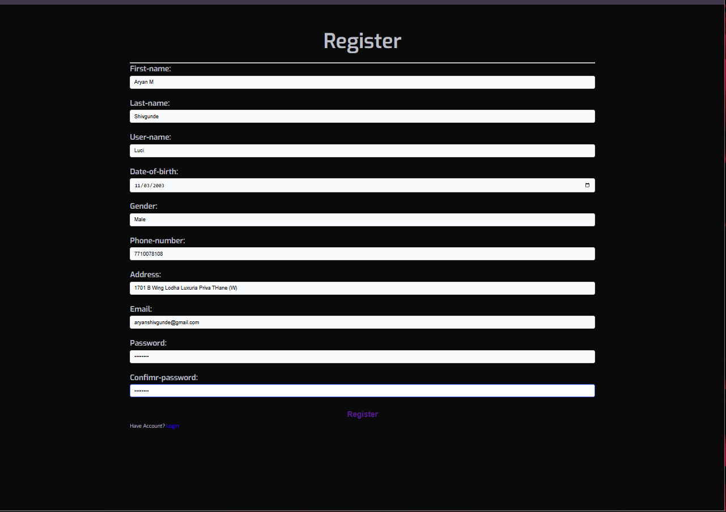

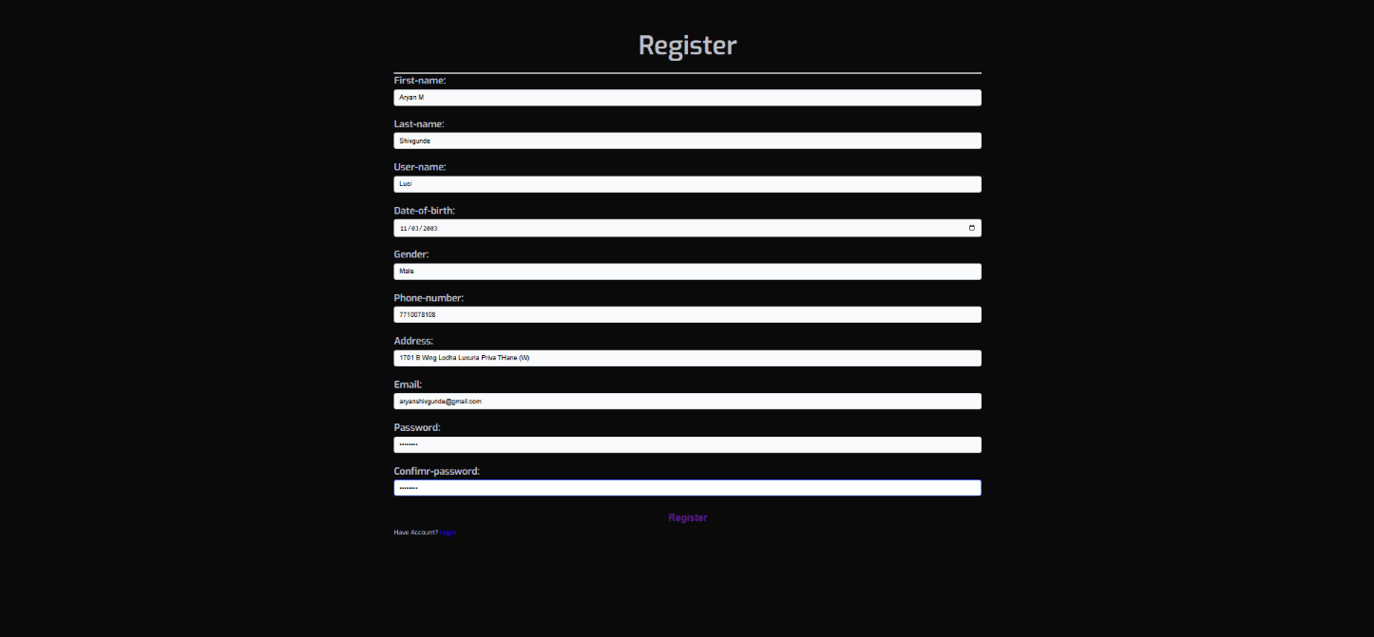

## 6.3.3 patient & admin Login page:

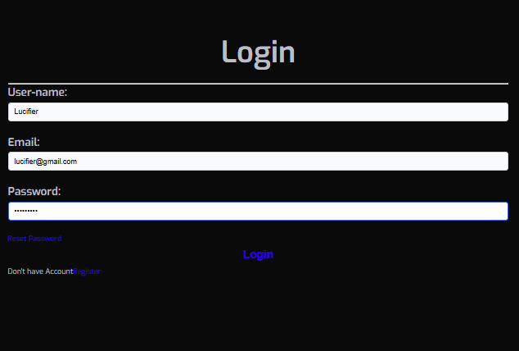

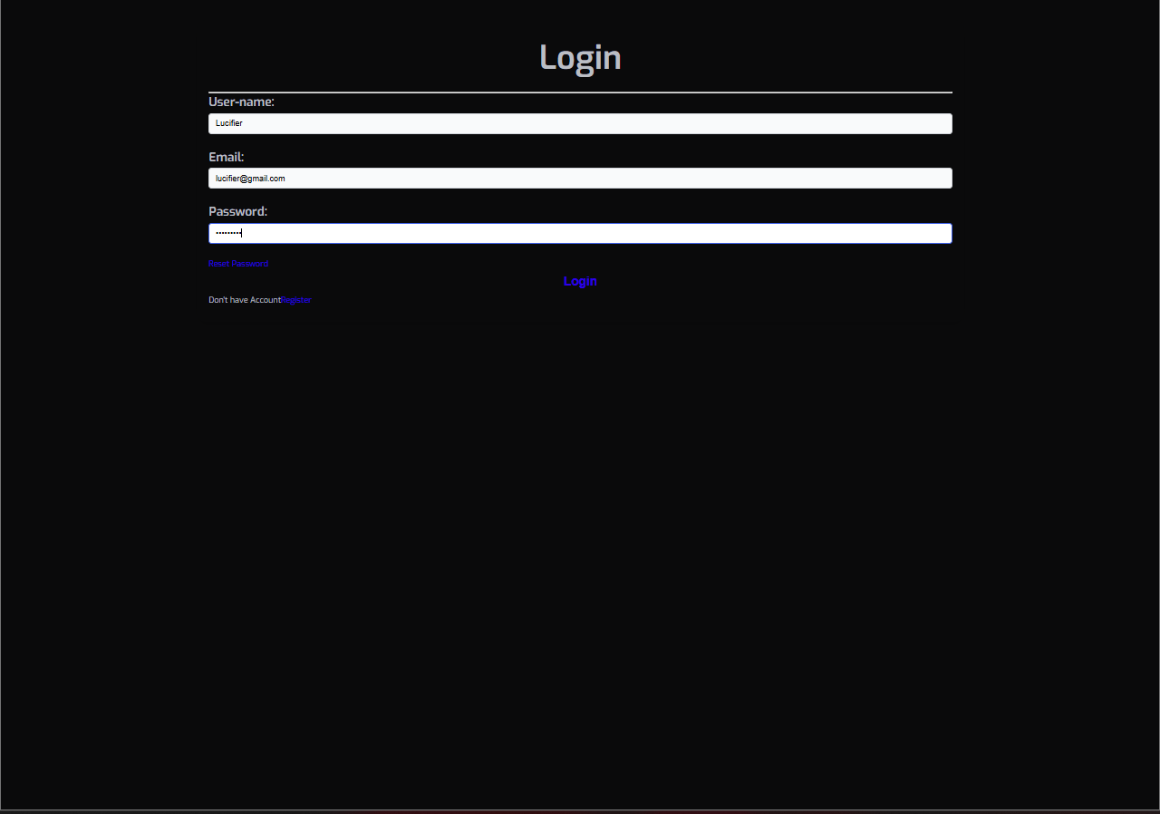

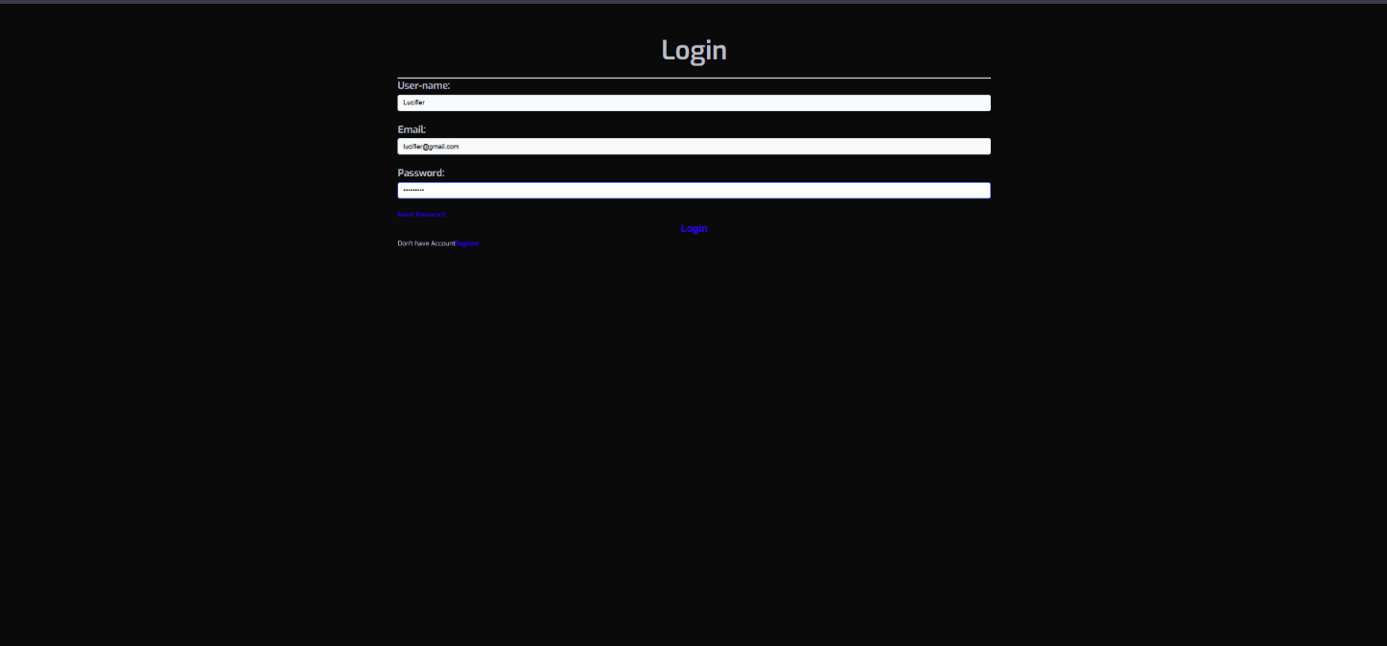

## 6.3.4 patient dashboard page:

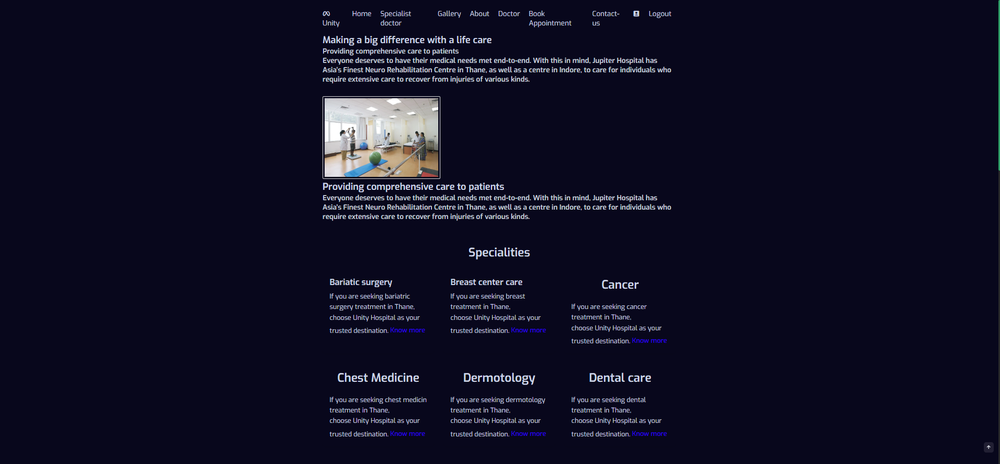

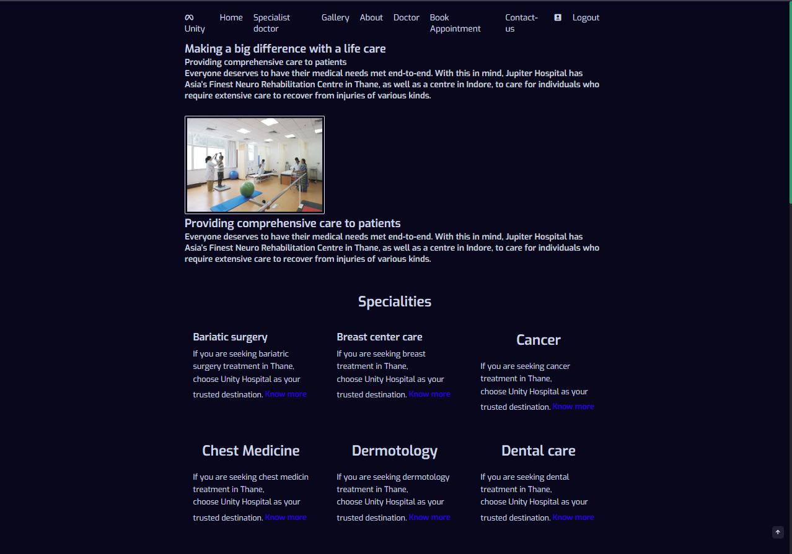

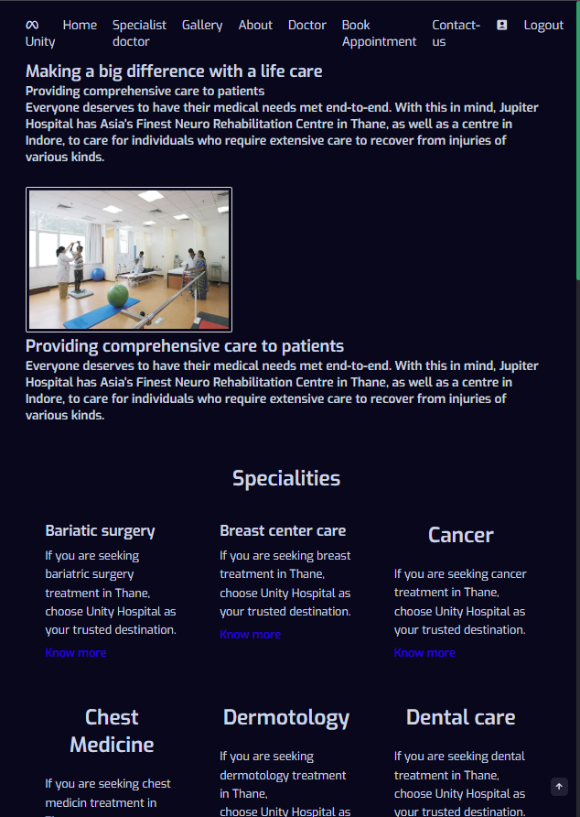

## 6.3.5 patient contact page:

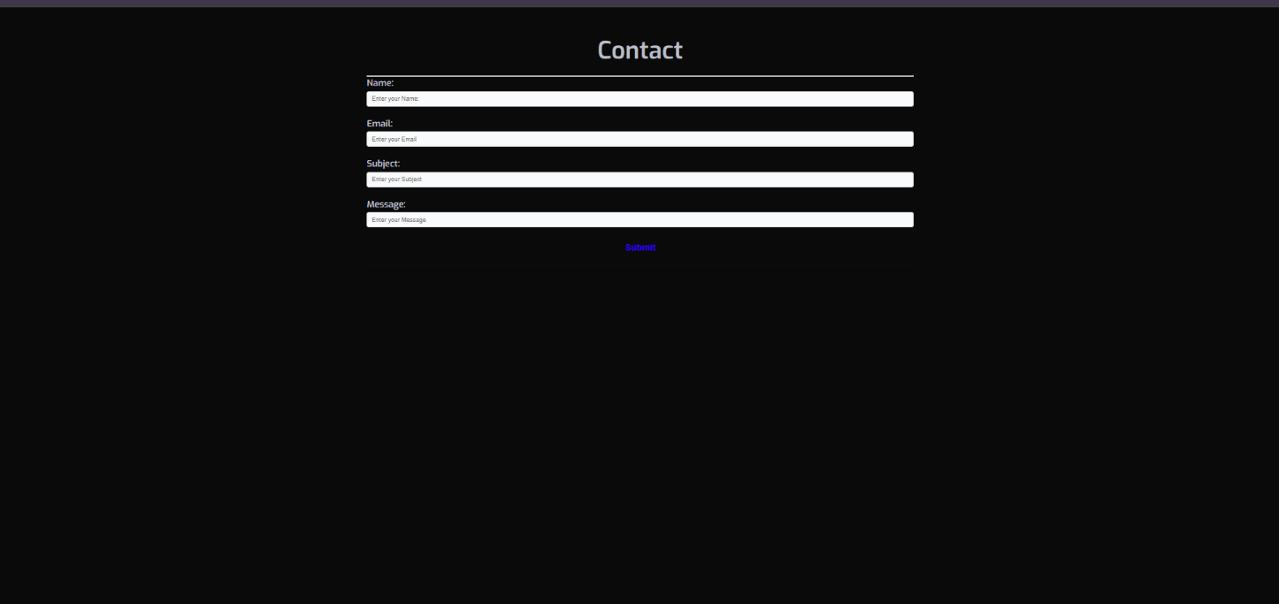

## 6.3.6 patient appointment booking page:

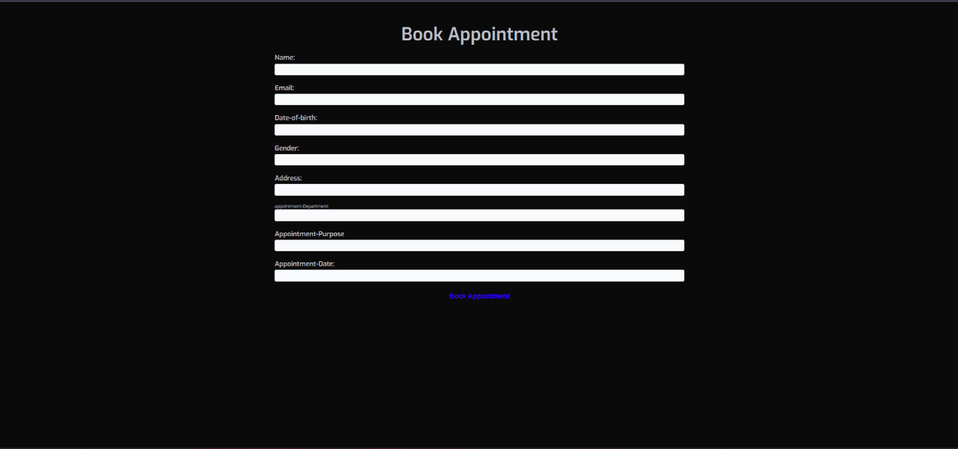

## 6.3.7 patient profile page:

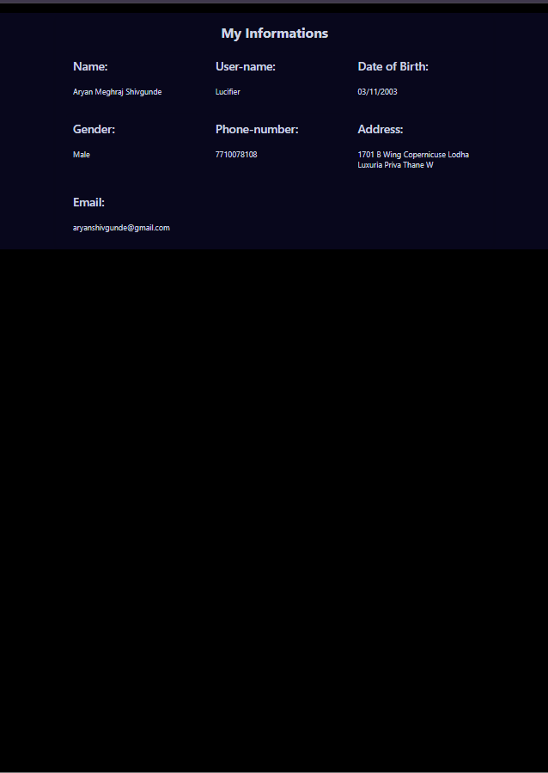

## 6.3.8 Doctor admin dashboard page:

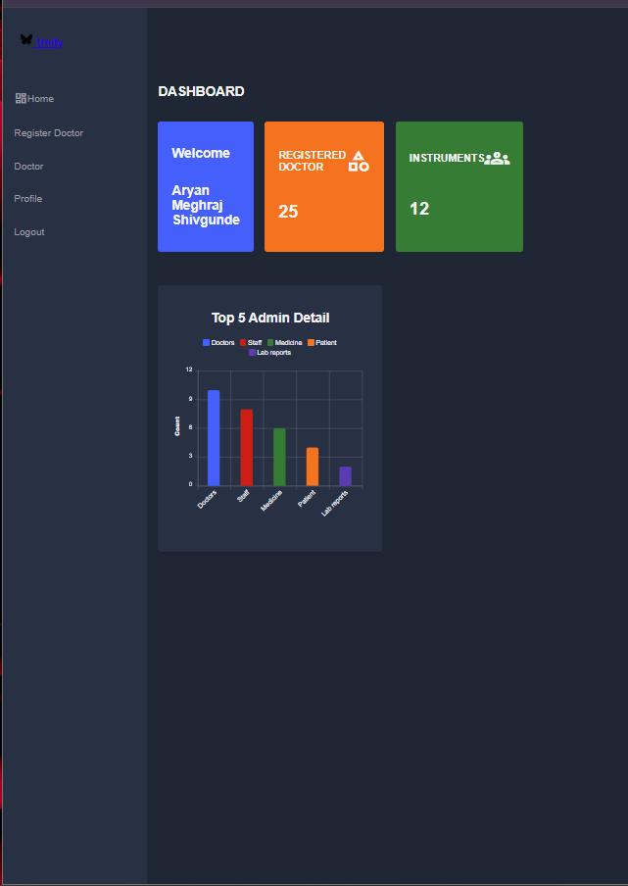

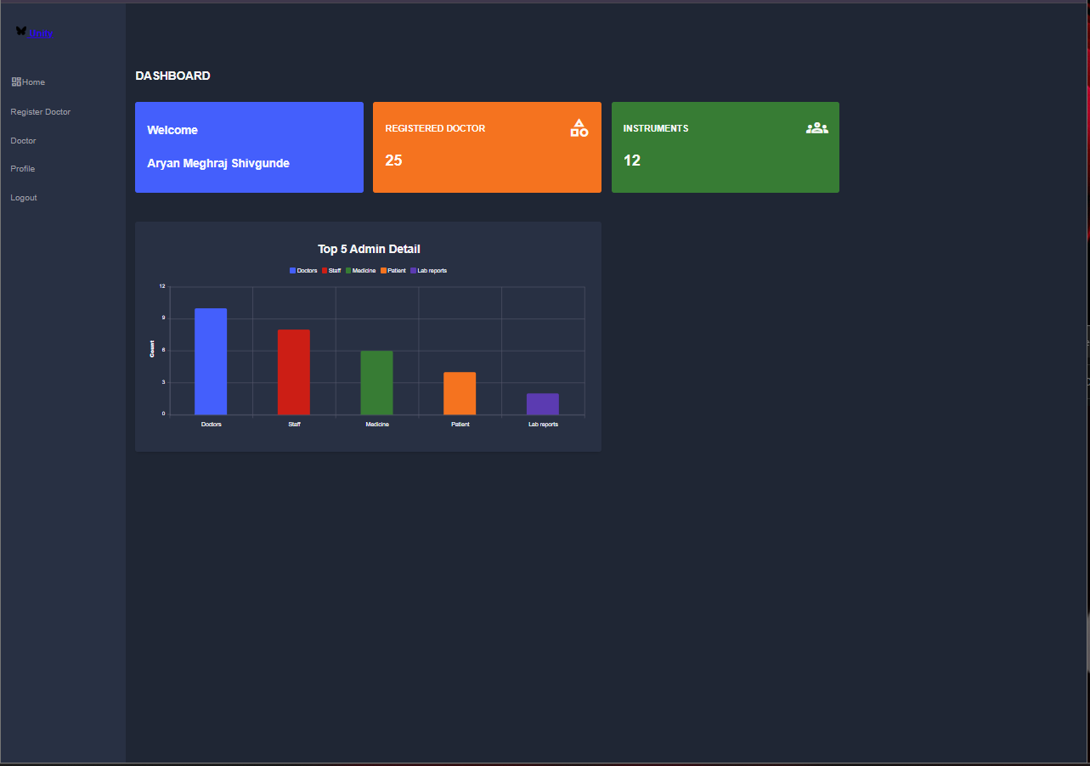

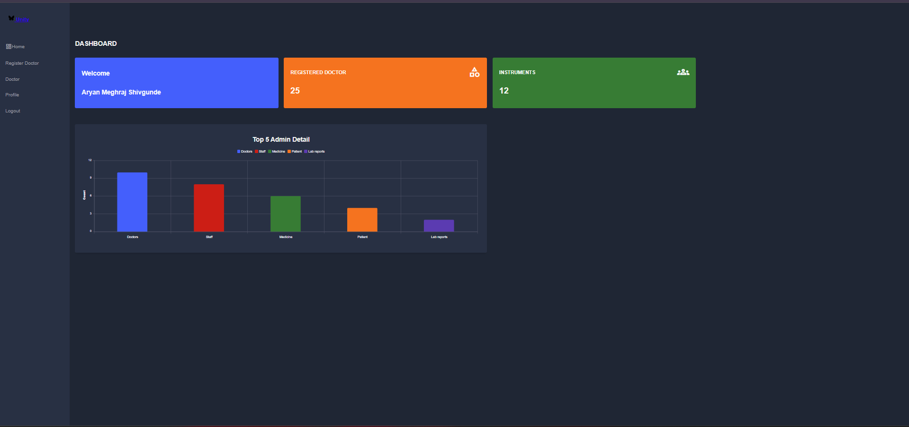

## 6.3.9 registered doctor in admin dashboard page:

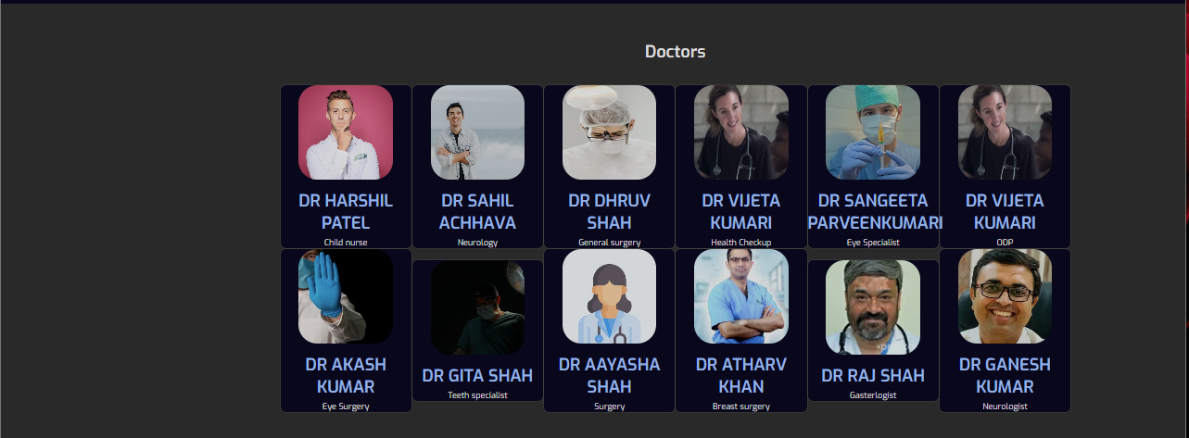

## 6.3.10 admin profile page:

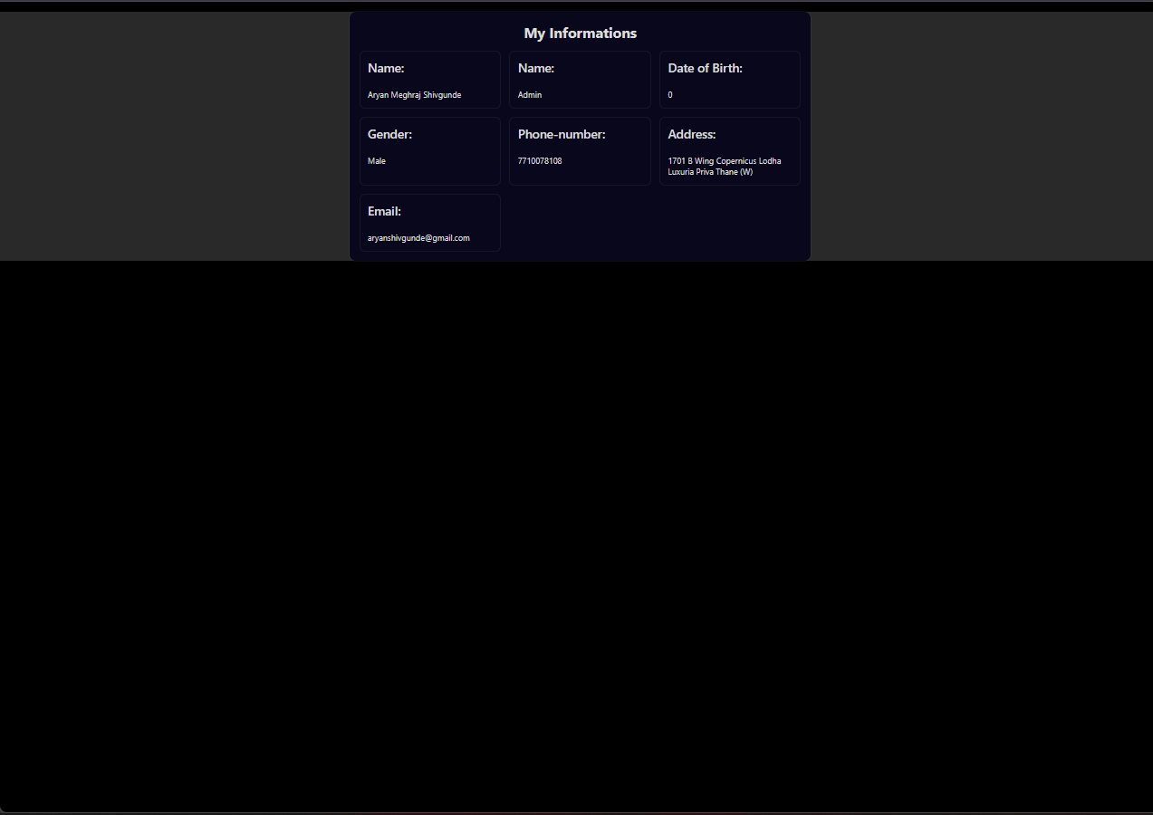

# testing

Testing process for the project, covering various aspects such as authentication, hosting, database operations, responsiveness, user interaction, and design, with explanations derived directly from Firebase documentation and other relevant sources:

1. Authentication via MS SQL server:
   1. In accordance with MS SQL Server documentation, extensive testing was conducted on user authentication mechanisms using MS SQL Server Authentication.
   2. This involved thorough examination of email and password authentication, ensuring secure sign-in functionality.
   3. Detailed checks were made to validate the handling of authentication tokens and user sessions, ensuring seamless user experiences while maintaining security standards
2. Hosting and SEO Testing:
   * 1. Following localhost guidelines, the project was hosted on localhost Hosting, with thorough testing performed to validate deployment and hosting configurations
     2. Localhost Hosting's SSL support and content delivery network (CDN) capabilities were evaluated to ensure secure and high-performance content delivery.
     3. Testing included checks for Search Engine Optimization (SEO) aspects such as metadata configuration, canonical URLs, and structured data markup, aiming to improve visibility and ranking in search engine results pages (SERPs).
     4. Page speed and performance metrics were analyzed using Localhost Hosting's integration with Google, with optimizations made based on insights derived from performance reports.
3. Responsiveness Testing:
4. In line with Localhost's recommendations for responsive web design, extensive testing was conducted to ensure optimal user experiences across various devices and screen sizes.
5. Testing involved the use of responsive design testing tools and emulators to simulate user interactions on different devices, including desktops, laptops, tablets, and smartphones.
6. Media queries and viewport settings were thoroughly tested to ensure consistent layout and styling across different viewport sizes in compliance with responsive design principles.
7. User interactions such as touch events and gestures were validated on touch-enabled devices, with adjustments made accessibility, to enhance usability and accessibility
8. User Interaction Testing:
9. Asp.net documentation on user interaction design principles served as a guide for testing user interaction features and functionalities.
10. Testing encompassed navigation patterns, input controls, form validation, feedback mechanisms, and other interactive elements, ensuring intuitive and user-friendly interactions.
11. Accessibility testing was conducted to assess compliance with web accessibility standards such as Web Content Accessibility Guidelines, with optimizations made to enhance usability for users with disabilities.
12. Usability testing sessions were conducted with representative users to gather feedback and identify usability issues, with iterative improvements made based on user feedback and usability testing results.
13. Design and UI Testing:
    * 1. Drawing from Localhost's UI design principles and guidelines, thorough testing was performed on the project's design and user interface (UI) elements.
      2. Visual design elements such as typography, color schemes, iconography, and layout compositions were evaluated for aesthetic appeal and visual consistency.
      3. Usability testing sessions included tasks related to navigation, content discovery, and task completion, with observations recorded to identify design flaws and usability issues.
      4. Cross-browser and cross-device testing was conducted to ensure compatibility and consistency of design rendering across different web browsers and devices.
      5. Feedback from design reviews and usability testing sessions informed iterative design refinements, with revisions made to improve user experience and visual presentation.

Overall, the testing process involved meticulous attention to detail and adherence to best practices outlined in Localhost documentation and other relevant resources, with the goal of delivering a robust, secure, user-friendly, and visually appealing web application that meets the project requirements and exceeds user expectations.

**Black Box Testing for “Unity Hospital Management System Website”**

* 1. **Authentication Testing:** Test user sign-in using email and password authentication.Verify the authentication process via email for account verification. Test the "forgot password" feature to ensure users can reset their passwords securely.
  2. **Database Operations Testing:** Test CRUD (Create, Read, Update, Delete) operations on MS SQL Server database collections. Verify the integrity and consistency of data stored in collections and documents. Test data access permissions defined by MS SQL Server security rules to ensure appropriate user access.
  3. **Hosting Testing**; Test website hosting on a chosen platform (e.g., Localhost Hosting) to ensure proper deployment. Verify website accessibility across different devices and browsers. Test website performance and responsiveness under various network conditions.
  4. **User Interaction Testing:** Test navigation features, such as on-screen buttons or arrow keys, for ease of use. Verify user interactions for booking appointment checking donation options, ensuring intuitive and seamless experiences. Test sharing functionalities, such as generating unique shareable links for users.

**White Box Testing for “Unity Hospital Management System Website”**

1. **Code Coverage:** Perform code coverage analysis using tools like Istanbul to ensure adequate test coverage. Verify that critical code paths, including authentication and database operations, are thoroughly tested.
2. **Control Flow Analysis**: Test different control flow scenarios in authentication processes, such as valid and invalid user inputs. Verify control flow paths for error handling and exception scenarios.
3. **Integration Testing**: Test integration between frontend (HTML, CSS, JavaScript) and backend (MS SQL Server Authentication, MES SQL Server Database) components. Verify seamless communication between client-side and server-side code for real-time updates and data synchronization.

**Testing Conclusion:**

By combining black box and white box testing techniques, "Unity Hospital Management System Website" can ensure both functional correctness and internal robustness. Black box testing focuses on validating user-facing features and interactions, while white box testing delves deeper into the internal logic and code structure. This comprehensive testing approach helps identify and address potential issues across all layers of the application, ultimately enhancing its quality, reliability, and user satisfaction.

# conclusion

1. **Reflections and Recommendations**: In reflecting upon the journey of designing and testing "Unity Hospital Management System Website," several key conclusions emerge, each shedding light on the application's strengths and areas for further enhancement. This conclusion encapsulates insights gleaned from the comprehensive black box testing process, offering recommendations for future iterations and user engagement strategies.
2. **Automation Enhancements**: One of the foremost observations is the transformative impact of automation on the system's efficiency and reliability. By streamlining processes and minimizing manual interventions, the application demonstrates heightened responsiveness and scalability. Future enhancements should prioritize further automation to optimize user experiences and backend operations seamlessly.
3. **Creative User Interface**: At the heart of "Unity Hospital Management System Website" lies its creative and user-friendly interface. This innovative approach to hospital management. Moving forward, continuous refinement of the interface's design and functionality will be paramount to ensure an engaging and intuitive user experience.
4. **Security Considerations**: While MS SQL Server offers robust security measures, it is essential to acknowledge the inherent limitations and potential vulnerabilities. While the application provides adequate security for typical usage scenarios, users are advised to exercise caution when inputting sensitive information. Adopting best practices, such as using unique passwords and refraining from sharing confidential data, mitigates potential risks and safeguards user privacy.
5. **Authentication Mechanisms**: The integration of authentication mechanisms, including email and password authentication via MS SQL services, ensures user data integrity and access control. However, users are reminded to exercise diligence in managing their account credentials and refrain from sharing sensitive information. Adopting a proactive approach to security awareness and user education will fortify the application's resilience against potential threats.
6. **Future Directions**: Looking ahead, the evolution of "Unity Hospital Management System Website" hinges on continuous innovation and user-centric design principles. Future iterations should prioritize enhancements in automation, user interface refinements, and security fortifications. Additionally, fostering a community-driven feedback loop and prioritizing user engagement initiatives will foster a vibrant ecosystem of “Unity Hospital Management System Website".

# future enhancement

In anticipation of future iterations and enhancements for "Unity Hospital Management System," a myriad of groundbreaking features and announcements are poised to enhance user experiences and propel the platform to new heights of progress:

1. AI-Powered Assistance: Harnessing the transformative power of artificial intelligence, the platform will unveil an awe-inspiring AI chatbot feature engineered to elevate the quality of hospital management system to unprecedented heights.
2. Continuous Updates and Bug Fixes: Embracing a steadfast commitment to excellence and user satisfaction, the platform will inaugurate a relentless cycle of updates and bug fixes. Bolstered by a robust customer support system, users will be empowered to voice their concerns and provide invaluable feedback directly to the platform's custodians. Through a symbiotic partnership between users and developers, every glitch will be swiftly rectified, every suggestion meticulously considered. With each update, the platform will evolve, metamorphosing into a paragon of reliability, innovation, and user-centric design.
3. Predictive Analytics for Patient Health Monitoring: Use machine learning models to analyze patient history and predict potential health risks (e.g., likelihood of readmission, chronic disease progression). Alert doctors and caretakers in advance for preventive action.
4. AI Chatbot for 24/7 Patient Support: Provide instant answers to patient queries about appointments, medications, and test results. Help patients schedule, cancel, or reschedule appointments seamlessly.
5. Automated Resource Optimization: Predict peak times for OPD and allocate doctors/staff accordingly. Improve inventory management by forecasting medicine and equipment demands.
6. Telemedicine and Remote Monitoring: Integrate secure video consultations and remote monitoring tools for follow-up care. Allow patients in remote areas to receive care without visiting the hospital physically

# bibliography

**HTML, CSS, ASP.Net MVC and JavaScript:**

W3Schools

Website: W3Schools

Resources: Comprehensive tutorials on HTML, CSS, Asp.net MVC JavaScript

YouTube Channels used:

* 1. Code Hub
  2. HVC Technology
  3. Code Affection
  4. Programentor
  5. Aranya Ehsanul Siddiq
  6. CodeWithZeeshan

**AI Driven Platforms:**

* 1. OpenAI ChatGPT

Website: OpenAI

Platform: AI-driven assistance for coding challenges and refinement

* 1. Google Gemini

Platform: AI-powered assistant for coding and problem-solving

* 1. Microsoft CoPilot

Platform: AI-driven code completion and suggestion tool